
Become a member and get a subscription to our 24-page print newsletter, Erowid Extracts

"It lasted for a million years and for a split-second. But it's over and now it's your turn." -Timothy Leary
QT's DMT Extraction for Students
Version 1.1
INTRODUCTION:
By Quantum Tantra
Archived from http://digilander.libero.it/irimias/dmt_guide.html
Also available at: http://www.spiritplants.com/articles/DMT.htm
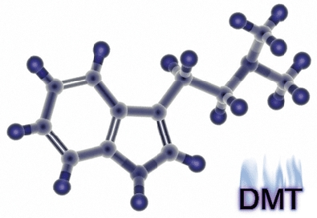

Name: | N,N-Dimethyltryptamine
Chemical Name: | N,N-Dimethyl-1H-indole-3-ethanamine
Alternative Chemical Names: | 3-[2-(dimethylamino)ethyle]indole, DMT
Chemical Formula: | C12H 16N2
Molecular Weight: | 188.27
Melting Point: | 44.6-44.8° (crystals)
Boiling Point: | 60-80° (crystals)
Dosages: | 60-100mg (smoking)
 | 350mg (orally)
Controlled substance (hallucinogen) U.S. Code of Federal Regulations, Title 21 Part 1308.11 (1985).
In modern times there has been a reduction of ritual. The ceremonies, that previously served to cast out an individual from modern associations and throw him into a field of epiphanies, have become merely form, betraying the inner forces that must somehow manifest. Shamen know of these inner forces. They understand the inevitable overwhelming psychological experience that everyone will face if they are to complete their inward path to open the unconscious and fall in. The psychological crisis is the fulcrum of any metaphysical realization the individual may have about himself or his world. Without these intense experiences, without the rituals that convey the message of the journey, and without shamen to show the way, many are lost in the world searching constantly farther for what is contained only within. To chemically force such spiritual breakthrough may be interpreted by some as a way to circumvent the trials that are necessary to test each soul willing to see the truth of their life. But in contemporary society where is the individual to seek these tests of the self or to be struck silent in awe of their own natural beauty or that of the universe? The shamen offered these opportunities to the individuals of their society for generations, helping people maintain a healthy psychology between the known world and the mystical. I now offer this ability to you in one of many forms, DMT.
DMT is perhaps the most powerful hallucinogen known to man. It is related to LSD and psilocybin. There are no drug tests that would show DMT usage. None of the basic NIDA-5 drug tests or any extended drug test will show a result for DMT. DMT is naturally formed in the body and has been found in abnormal levels in the body fluids of persons suffering from schizophrenia. DMT is almost never sold through dealers, rarely synthesized, and seldom used. It is, however, easily extracted from common plant materials and has been used in various forms for hundreds of years ( timeline.) DMT is not a "social drug" however. Respect the drug and it's incredible potential. This drug is not for the inexperienced, nor is it recommended to those who are just looking for another "high." Few seek the visions enabled through DMT, and even fewer return to them. Even avid psychedelic users have had frightening experiences with DMT on their first encounter with the drug. Take care to research and find out if DMT is for you. I stress that educating yourself about this drug (and about all drugs you intend to use) will make you a more competent and prepared chemist, tripper, and guide.
This manual is presented as a quick bench guide for the complete novice on how to extract DMT. Although the text and illustrations for the process were all created by myself, there are a few pictures which are not my own. The origins of these pictures are credited in the bibliography. I would like to encourage others to add to this manual their own written observations. When attempting to produce any of these products the reader is encouraged to read through the steps several times to closely familiarize himself with the entire process. Please take note that DMT is an illegal substance in the United States of America and is controlled under federal regulations. The following is for educational purposes only.
How to Extract DMT from Natural Sources
(in Ten Easy Steps)
First a plant must be selected that contains the chemicals we wish to extract. None of these plants are illegal and they can be found growing wild and free all over the world (much less can be said for some of our other favorite plants.) Most of these plant materials can be ordered through the internet. A little research may reveal a large quantity of some useful plant material growing near you. Alkaloid contents of each plant mary vary according to the growing conditions. Specifics about these plants and how to grow them are beyond the scope of this manual but the information can easily be found. Below is a chart of several plants that contain NN-DMT, 5-OH-DMT, and 5-MeO-DMT (DMT's close cousin.)

Alkaloids reported as (mg) per (100g) raw dried plant, and as percent of total plant source weight:
 | Acacia bark
 |  | 0.71% | NN-DMT
 | Acacia maidenii bark
 |  | 0.36% | NN-DMT
 | Acacia simplicifolia bark
 |  | 0.86% | NN-DMT
 | Mimosa hostilis root (bark)
 |  | 0.57% | NN-DMT
 | Virola shoots & flowers
 |  | 0.44% | NN-DMT
 | Desmanthus illinoensis root (bark)
 |  | 0.34% | NN-DMT
 | Pilocarpus organensis
 |  | 1.06% | 5-MeO-DMT
 | Phalaris tuberosa
 |  | 0.10% | NN-DMT
 |  | 0.022% | 5-MeO-DMT
 |  | 0.005% | 5-OH-DMT
 | Phalaris arundinacea ('net gossip)
 |  | 0.060% | NN-DMT
 |  | ?? | 5-MeO-DMT
 | Psychotria species (averaged, from Jonathan Ott)
 |  | 0.200% | NN-DMT

N,N-DMT |  | DMT (N,N-dimethyltryptamine) is one of the most hallucinogenic compounds known. DMT is not active orally (unless in the form of an ayahuasca brew), but must be smoked in it's freebase form to experience its effects. (DMT can be taken orally when mixed with a MAOIs, but this is not recommended for the first time user.) The body quickly builds a tolerance for the drug. Your DMT dose must be taken within 60 seconds. Any more of the drug after this first minute will not enhance the experience. It is recommended to give at least one hour before attempting another DMT trip.
5-MeO-DMT |  | Effects of 5-MeO-DMT are psychedelic without the visual distortions found in NN-DMT. 5-MeO-DMT is taken at 1/4 the dose of NN-DMT and will overpower the NN-DMT.
5-OH-DMT |  | (Bufotenine) can cause severe physical discomfort including circulatory distress, nausea, psychological distress (panic and fear), severe skin flushing, and has the possibility of being fatal.
MAOI |  | (Monoamine Oxidase Inhibitors) will intensify and prolong the effects of NN-DMT, however this is never recommended. Foolish combinations of MAOIs and other drugs can lead to serious health problems and even death. The tryptamines are normally metabolized by an MAO in the body. MAO metabolizes serotonin, norepinephrine, and dopamine. By inhibiting this, MAOIs increase levels of those neurotransmitters. Tyramine will not be metabolized and will cause an increase in tyramine levels in the blood.
Extraction Procedure
For our experiment we will be using Mimosa hostilis root-bark to provide a very pure product of NN-DMT without the over powering influence of 5-MeO-DMT or the negative side effects of 5-OH-DMT. For a solvent we will be using common naphtha. Notes on adaptations for chemicals and other variations of this process are described as well. The following is a list of materials:
It helps to test all non glass materials with solvents to make sure there aren't any adverse reactions.
1. Mimosa hostilis root-bark |  | (30g suggested starting amount - $45/100g)
2. Muratic acid |  | (pool acid - $4/gallon)
3. pH papers |  | (litmus papers - $3/100 tests)
4. Lye |  | (Red Devil Brand - $5)
5. Naphtha |  | (Zippo lighter fluid - $5)
6. Coffee filters and cotton swabs/cloth |  | ( - $2)
7. Funnel |  | ( - $2)
8. 3 labeled glass jars with lids (thick canning jars work best, but pickle jars will do) |  | (labeled Jar A , Jar B, and Jar C - $3)
9. Evaporating dish |  | (glass baking pan - $10)
10. Glass pipette |  | (turkey baster - $4)
11. Goggles and gloves |  | ( - $10)
12. Distilled water |  | ( - $2)
 |  | Total = ~$100.00
STATEMENT OF HAZARDS: Methylene Chloride
Suspect cancer hazard. Risk of cancer depends on duration and level of contact. Harmful if swallowed. Causes skin and eye irritation. Causes respiratory tract irritation. May affect blood cells. May affect the central nervous system. May cause blindness. Avoid breathing vapor or mist. Handle with caution. Keep in mind these risks whenever substituting DCM for any other solvent.
STATEMENT OF HAZARDS: Muratic Acid
STEP 1
Preparing Plant Material

Grind the plant material to a fine powder. The finer ground the material the better your yields will be. The best technique to pulverize and rupture the cell structure of any plant material is to repeatedly freeze and thaw it over and over again. An example of a plant requiring this treatment is Phalaris arundinacea, a strong and limber grass. Mimosa hostilis root-bark is easily pulverized to a fine powder in a blender, releasing a pink haze. |  | 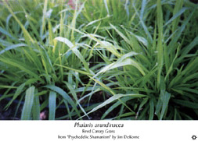  Above photo credit to Jim DeKorne  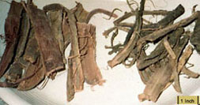  Mimosa hostilis root-bark  © 2000 Erowid
  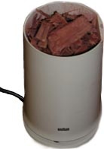
    A. |  | First place the grass clippings in the freezer over night.
    B. |  | Remove them and place the frozen clippings into a blender. Try and liquefy the clippings as much as possible while they are frozen.
    C. |  | Repeat this process of freezing, thawing, and blending with the plant material several times for best results.

STEP 2
Acidify Water to pH 2

 |  | 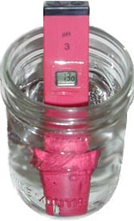  electronic pH meter in jar  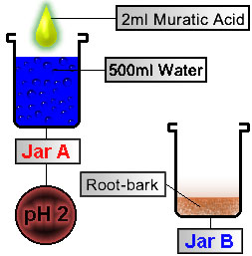  Figure 1
  Take two pickle jars (about 20 ounces each) and wash them in the dishwasher to help sterilize and clean them. Label the jars A and B. Fill Jar A 2/3 way full with distilled water (~15 ounces, or ~500ml filtered preferable.) Pour 1/2 teaspoon (~2ml) of acid into Jar A . Test the pH of the water in Jar A . The pH of the water should read 2 If not, add more distilled water to dilute (5% acidity). There are many sources of acid: (Always add acid into water, not water into acid. Use distilled water to avoid any adulterates.)
  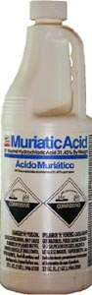
    A. |  | Distilled white vinegar (5% acidity, ~2 cups, or 500ml for every 50g root- bark) or lemon juice.
    B. |  | Muratic acid from pool shop (10ml 30% HCl to 1 liter water is recommended.)
    C. |  | Reagent grade hydrochloric and sulfuric acid (over-poweringly potent without dilution.)
  Add powdered root-bark to Jar B.
   |  | Lab Notes:
   |  | Proper method of testing pH with pH papers; Use a glass stirring rod (or something that won't corrode with acid) to stir the acidic solution. Dab the pH paper with the stirring rod lightly. To save pH paper, you can cut only a small section of strip for a single test. If a pH meter or pH papers are unavailable there are certain organic sources that produce antocyanines which change color with different pH ranges. Red beats or red cabbage may be used to produce a rough estimate of pH range. This is not always recommended, but it works. To create the indicator solution, blend or grind either red beats or red cabbage. Strain off the juice from the pulp and filter out any remaining plant material. If not enough pigment is found, try extracting more with water from the mushy pulp. If there is too much pigment, simply dilute solution with water. Indicator solution produced has a short shelf life but can be stored in a refrigerator for several weeks. Below is a rough pH chart for reference: (litmus paper comes with its own pH chart)
  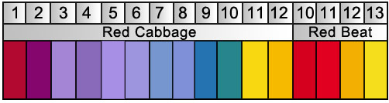
STEP 3
Convert Alkaloids to Salts

Using a pipette (or turkey baster) transfer enough acidified water from Jar A into Jar B to cover the root-bark in the bottom of Jar B (~8 ounces, or 250ml acidified water into Jar B.) When the acid reacts with the root-bark, it converts the alkaloids (elf-spice) into salts. To help facilitate this process we can:  Allow the contents of the jar 24 hours to react the first time. The alkaloids (tryptamines) are converted into salts and become water soluble. Our elf-spice is now contained in the aqueous solution. |  | 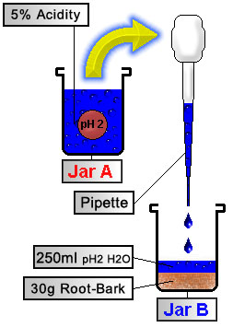  Figure 2
  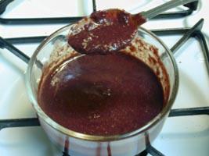
    A. |  | Periodically shake the contents of the jar. This helps more root-bark come in contact with the acid.
    B. |  | The weaker the acid, the longer it should be heated for. Do not allow evaporation of the liquid inside. Do not boil. Maintain temperature below 50° C or 122° F. Since we are using pickle jars, and not pyrex, they can shatter easily if heated or cooled too quickly. It is recommended using a double boiler with hot (not boiling) water to warm the solution. To cool, simply turn off the heat source and allow the solution to slowly return to room temperature.
      1. |  | When using muratic acid, heat the jar for 15-30 minutes.
      2. |  | When using weaker acids, simmer the contents overnight.
STEP 4
Filtration

Plug the bottom of the funnel with cotton balls or cotton cloth to create a cotton-filter. Pour the contents of Jar B through the funnel and into Jar C. Squeeze the root-bark contents inside the filter to press out the remaining juices. Save the root-bark that has been caught by the filter and place it back into Jar B. |  | 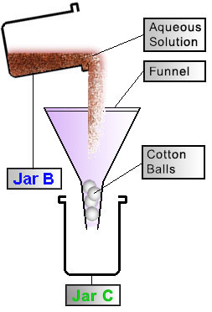  Figure 3
   |  | Lab Notes:
   |  | Whether filtering material through a cotton-filter or a coffee filter it helps if the thinner parts of the solution are filtered first, followed by the mushy and more bulky components (which may clog the pores of your filters as you strain.) The better your filtration, the more rapid and efficient your emulsions, also resulting in a cleaner product. Cotton must be specifically used. Other fibers have the potential to react with our solvents. A tea strainer (wire strain) can be a simple way to separate bulk ruffage. Another way to improve this method is to use a vacuum filter. There are several varieties, the most affordable being a water vacuum filter that attaches to a household faucet. These cost about $30.00 and are very quick, useful and effective. | 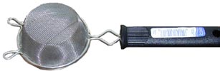  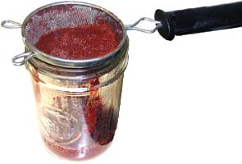
STEP 5
Collect 3 Extractions
Repeat the process outlined in STEPS 2, 3, and 4, two more times. The initial extraction is most important. For best results, allow the contents of the jar more time to react during the remaining two extractions. Shake Jar B, 4 times a day, for 1 week before filtering each time through a cotton-filter. Collect the acidic contents in Jar C each time. After these initial 3 cotton-filtration cycles, clean Jar A and Jar B, and dispose of remaining root-bark.  After all 3 extraction phases, filter the contents of Jar C again, this time using a paper coffee-filter instead of a cotton filter.  Repeat this process as necessary to remove as many of the particulates from our solution as possible. |  | 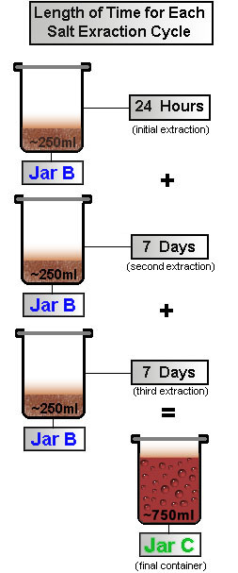  Figure 4
  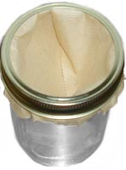 |  | 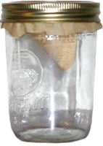
    A. |  | Place several paper-filters (coffee filters) in the bottom of the funnel.
    B. |  | Strain contents of Jar C through the paper-filters and into Jar B.
    C. |  | When finished, clean Jar C.
  Lab Notes:
  The majority of the alkaloids we are searching for will convert to salts in the first extraction phase. The second and third extraction phases take place over a longer period of time. This will ensure that we will be able to extract as many alkaloids as possible from our material. The third phase can be reduced to 1-2 days but will not produce the best yields. Remember, these measurements are all crude estimates.
STEP 6
Defatting
Next we defat the solution. This is part of standard lab procedure whenever extracting alkaloids of this sort. This process removes the oils, fats, and other unwanted substances from our aqueous solution and also helps with yields. All DMT salts are insoluble in non-polar solvents -- with the exception of DMT acetate -- which is soluble in chlorinated non-polar solvents such as chloroform and DCM. Thus if you are using white vinegar (acetic acid) as your acid, you will need to use naptha or ether to defat as chloroform or DCM would extract the DMT acetate along with the oils and fats, defeating the purpose of this step.When using mimosa hostilis root-bark you may find this step unnecessary, however, any plant material foliage containing chlorophyl it is strongly recommended. To do this we add an organic (non-polar) solvent to the acidic solution. Before using any solvents test a significant amount (~500ml) of the solvent by evaporating it in a dish. This will verify that there are no residues or orders left when evaporation is complete (commonly found in many over-the-counter solvents.) Later in the procedure (STEP 10) you will be evaporating this solvent to leave a smokable form of DMT. Anything your solvent contributes, you may be smoking in the final product. Below are listed several more common organic non-polar solvents.  It is important to remember what type of organic solvent you use. For our defatting process we will use naphtha.  Add to Jar B ~50-100ml (~2-3.5 ounces) naphtha. (Only 10-15% the volume of our acidic solution is enough naphtha for this step. Visualize what 10% of the total of the solution is and add that amount of naphtha into the jar.) Cap the lid on Jar B and shake the contents vigorously for 20 minutes. Set Jar B aside and allow for emulsion (foam, bubbles, solutions, particles, etc.) to separate into two distinct layers (much like oil and water will separate.) This may take ~24 hours (48 in some cases.) The oils and fats will migrate into the non-polar solvent layer leaving our alkaloids in the aqueous solution. Since we are using naphtha, the solvent layer will rise to the top of Jar B. Using a pipette (or turkey baster) remove the solvent layer and discard.  Repeat defatting process 2 times. |  | 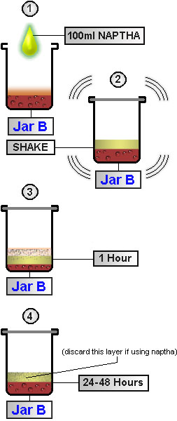  Figure 5  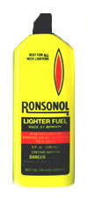  Naphtha  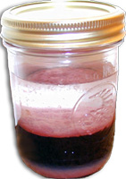  Defatting process  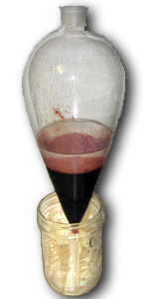  Seperatory Funnel in Jar
  A. |  | Naphtha:
   |  | Coleman fuel, VM&P naphtha, Zippo, or lighter fluid. Evaporate a small amount in a dish and inspect the residue if you are unsure of it's contaminants. If used for the extraction phase instead of the defatting phase, warm naphtha will extract alkaloids much better than cool naphtha. Naphtha is considered more selective for catching these alkaloids than DCM. Naphtha rises to the top of the jar.
  B. |  | Methylene Chloride:
   |  | Also known as DCM or dichloromethane. Often used as an adhesive solvent for acrylics. Pure DCM can be found in craft stores. DCM must be distilled first from all non-flammable paint strippers beforehand (they contain a paste that holds several unwanted substances.) The paint stripper may also contain methanol (most marine grade paint strippers are 80-90% DCM.) Methanol is also an organic solvent. DCM distills at 41° C or 106° F. Pure DCM is best. May cause cancer and blindness. Take necessary precautions. Methylene chloride sinks to the bottom of the jar .
  C. |  | Ether:
   |  | Contained in engine-starting fluid purchased at automotive stores. To remove liquid ether from an engine-starting aerosol can, spray the contents of the can down a 12 inch (~30cm) length of 3/4 inch PVC pipe. The ether will condense on the sides of the pipe and fall into the jar, while the inert propellant will be released into the air. Ether is extremely volatile. Ether floats to the top of the jar.
  D. |  | Chloroform:
   |  | Chloroform (CH2C12) can be purchased over the internet from arts and crafts warehouses. It has a tendency to be harsh on organics and has a boiling range of 35-65°C (95-149° F). Chloroform sinks to the bottom of the jar.
  Lab Notes:
  A separatory funnel is very handy for dividing and eliminating layers of solutions. This device consists of a single chamber with a tapered bottom. On the bottom is a closed faucet. The container is filled with the two solutions and they are mixed. After mixing, the apparatus is set aside until both fluids separate into two distinct layers. The lower fraction of the fluids can be drained via the bottom faucet and into a container for preservation or to discard. A quick separatory funnel can be made by filling a Ziplock plastic baggie with your mixtures, and hanging it from one corner. When the layers have separated, the bottom corner of the bag is pinched and then cut for drainage. It is suggested to test the baggie to make sure your solvents will not melt it.
  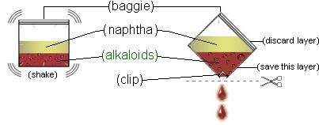
STEP 7
Prepare to Basify
In this step we will be preparing the solution for the alkaloids migration using a common organic non-polar solvent. For our solvent we will use warm naphtha (other solvents are identified in STEP 6.)
Add to Jar B 100ml (~3 ounces) warm naphtha. Shake the jar for 5 minutes.
STEP 8
Basify to pH 9
Now we must basify our solution. By doing this we will "unhook" the salt and transform the alkaloid into its "free base" form. The alkaloids will no longer be a salt, nor will they be soluble in water. This allows us to extract them with the organic solvent added in STEP 7. Ammonium hydroxide is normally used, but for our experiment we will be using NaOH found in household lye crystals (Red Devil drain cleaner) and purchased at hardware stores. Lye is very caustic and can react violently. Take the proper precautions when using lye.  A good mixture for basifying is 5g (~0.2 ounces) lye mixed with 95g (~3 ounces) distilled water. The reason we dilute the base is to prevent localized pH spikes which will destroy the alkaloids in the area that we are adding the concentrated base. Create a basic mixture as follows:  Now using a pipette transfer small amounts of solution in Jar A into Jar B.  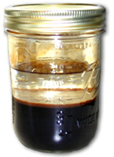  Approximate Basification Color  You have now formed the free base alkaloids that are soluble in non-polar solvents. According to the Merck Index the pKa (natural pH) of DMT is 8.68 (which would make this the ideal pH to extract at.) In many experiments the average pH of the final basified solution in STEP 8 was ~10, which gave satisfactory results everytime. |  | 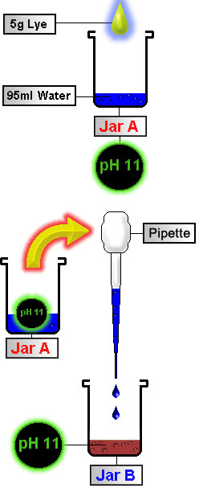  Figure 6
  A. |  | Fill Jar A 95ml (~3 ounces) full with water.
  B. |  | Slowly add 5g (~1 teaspoon) of lye to water. Shake and mix contents thoroughly.
  C. |  | Test to make sure pH is ~12.
  A. |  | Stir and check the pH of contents in Jar B after each transfer of lye solution until the solution in Jar B reaches a pH of ~9-11.
  B. |  | Shake the jar but be careful of pressure that will build up inside the jar. Release the lid and vent often! The solution will change a gray color as the alkaloids are turned from acid salts to free base. It may resemble a thick gel. Then the solution will turn black and slippery as you add more base. The jar will heat up during this process.
STEP 9
Emulsions
As these alkaloids dissolve in non-polar solvent added in STEP 7 , an emulsion will form. The strength of emulsion formed is directly proportional to the strength of stirring. Heavy, rapid stirring produces a thick emulsion that takes up to 4 days to settle out. Light, slow stirring over a longer period of time produces and emulsion that separates quickly without affecting the yield. Let the jar sit overnight until the emulsion has separated into two distinct layers. If emulsion has not cleared in 48 hours, try the following:  The naphtha will create a thick orange/pink emulsion with small bubbles that sometimes takes over 48 hours to separate. Always wait a few days before trying other methods to break down the emulsion. Keeping the naphtha warm will increase the amount of alkaloids it carries with it during each extraction. To help keep the jar warm, place it in a pot surrounded by warm water. Naphtha floats. If DCM is used for our extraction solvent in STEP 7, we will have a faster resolving emulsion than naphtha (less than an hour in some cases.) The solvent may turn a slightly darker color, usually only a tint of reddish-brown or yellow. DCM sinks. Allow a minimum of 24 hours for the contents of the jar to react completely. If using methanol allow a minimum of 4 days warmed to room-temperature for reactions to complete.  Using a pipette remove the corresponding solvent layer from Jar B and save it in Jar A. |  | 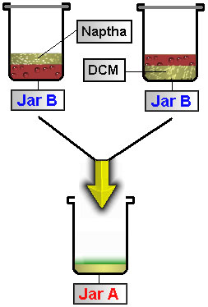  Figure 7
  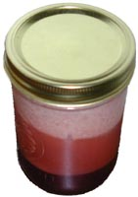  Thick emulsion
    A. |  | Sometimes adding a lot of salt and gentle stirring will make the polar layer more polar and help with emulsions.
    B. |  | Add more organic solvent.
    C. |  | Filter solutions again through a cotton filter several times. A paper filter will not work.
    D. |  | Test and increase the pH.
    E. |  | In most cases the solvent layer will have slight tint or may sometimes appear completely clear. If you want an early test of your extraction simply evaporate a small amount in a glass dish. The residue left should smell a bit synthetic (a smell like plastic.) This smell is a trait of your tryptamine.
STEP 10
Final Alkaloid Extraction and Evaporation
Repeat STEP 7 and STEP 9 (in that order) 2 times. Our elf-spice falls from the basified aqueous solution and into our solvent.  The combined solvent fractions from our solvent extractions should now be in Jar A. Pour contents of Jar A into a glass baking dish. Allow for the solvent to evaporate. Evaporation may take up to one week (depending on your solvent.) During this time keep dish with solvent away from heat or open flame.  The remaining substance may resemble anything from a sticky orangish goo to white or pale-orange crystals, depending on how well you followed the procedure. Scrape up this substance from the baking pan with a razor. About 25mg is a good starting amount (try about the size of a pea.) Assuming best yields you could get 5-6 doses (275mg) from 30g mimosa hostilis root-bark. You will know when DMT is in the final product by the smell. DMT has a distinct synthetic smell, almost like some manufactured plastics. |  | 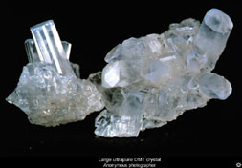  © 2000 Erowid  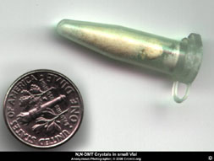  ©2000 Erowid  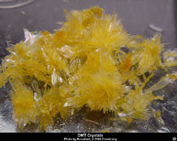  © 2000 Erowid  Photos of DMT crystals taken from The Vaults of Erowid
  "Don't worry about weighing it. Smoke it 'til your high, then save the rest for next time. Remember the flame should never touch the dmt, just the glass that's holding the dmt. Just heat up the "bulb" and gets to toking. Slow & steady, deep inhalation, hold the smoke 'til you burst. If nothing after 1st hit, huge toke again, etc. The 3rd toke will usually be the one."
  Lab Notes:
  After DCM has evaporated your product may contain trace amounts of hydroxide. Some find hydroxide to be unpleasant in the final product. To help reduce this try washing the DMT crystals in water, and letting the water evaporate. Water can be added to the solvent evaporating dish to help carry off hydroxide.
Lab Notes from Previous DMT Extractions

LAB #1

Materials
- 25g mimosa hostilis root-bark
- Pool acid
- Litmus Papers
- Red Devil Lye
- Distilled Water
- Coffee Filter and Cotton T-Shirt
- Plastic Funnel
- Pickle Jars
- Baking dish and Turkey Baster
- Cooking Pot
- Lighter Fluid

Day 1: |  | The root-bark is brittle. To powderize it one had to simply place the sticks of dried bark into the blender. They were immediately ground to a fine powder without any trouble, giving off a pink haze when the cover of the blender was released. The powder was stored in a tupperware container and placed in the back of a freezer.
Day 2: |  | Muratic acid is powerful. Thick gloves were worn along with eye protection. Using a stainless steel teaspoon, about 1-5ml (1 teaspoon) of muratic acid was poured into a pickle jar that contained roughly 3/4 filtered water (15 ounces or about 500ml.) The pickle jar was previously washed twice in a dishwasher in an attempt to ensure sterility. Under the lid of the pickle jar the manufacturer had painted on a thin ring of some type of latex or rubber to help seal the jar. The mixture of water and acid do not seem to affect the ring (it doesn't dissolve or melt the latex in any way) so the jar and its lid were used.  The jar was shook to mix the acid and water. Immediately afterwards the pH of the water was tested. The pH was 1 using pH papers to measure. (Compare pH within 30 seconds with litmus.)  Added the 25g root-bark to the bottom of jar B. Then the baster was used to pour enough acidified water to just cover the root-bark. Then jar B was capped and shook vigorously for 10 minutes. While shaking the jar it began to foam up with pink foam. Then the jar rest for a couple hours. The contents of the jar broke into 3 layers. The top was pink foam. The middle was a very very dark red (burgundy) color. Light didn't seem to pass through it very well at all. The bottom layer was a lighter red sediment.
Day 3: |  | The dark red color of the top layer of liquid has now turned almost black it seems. No light passes through it.
Day 4: |  | It was decided to heat the solution for several hours in an attempt to speed up the process. The jar and it's contents were propped up on a porcelain stand inside a cooking pot. To this pot was added enough water to surround the pickle jar. The lid to the pickle jar was made finger tight so that the contents could not evaporate but still allow pressure to escape. For roughly 3 hours the mixture sat in very warm water (not boiling.) Occasionally one would lift the jar, and shake the contents before placing it back on the stand. Afterwards the heat source was turned off and the water and the pickle jar contents cooled to room temperature.
Day 5: |  | A funnel was placed in the empty jar A. Inside the funnel was placed a cotton T-shirt filter. In jar B the root-bark and the solution had formed two layers. This made it easier to sift the smaller particles through the filter before the larger particles clogged the pores of the filter. After the filter was full of sediment I took the edges of the filter and twisted to squeeze any remaining liquid into the second jar. The process was repeated until the jar B was empty. Then jar C was filled with roughly 2/3 filtered water, and was added roughly 5ml of muratic acid. The cotton filters were opened again, and the sediments they held were poured back into the jar B.  Both jars were capped tightly and checked for leaks again. Needless to say anytime one is working with these chemicals one should wear thick gloves and the proper eye and body protection.  Acidified water from jar C was siphoned with a turkey baster into jar B until the water covered the sediments. The contents of the jar were again left to sit in warm water, this time about 30 minutes.
Day 6: |  | Strained aqueous solution and collected. Added acidic water to remaining plant material. Simmered for 30 minutes.
Day 9: |  | Final collection of aqueous solution. Plant material was thrown away. Solution was strained 3 times through coffee filters.  Naphtha (Lighter Fuel) was added. About 100ml. The jar was shaken vigorously for ~10 minutes, resulting in a thick bubbly solution. This was allowed to rest for 24 hours. After 24 hours the top layer resembles water with a few drops of milk added. There is also a layer of translucent pink scum. This this is the nasty stuff we want to get rid of.  To remove the naphtha layer (top layer) it was agreed that it would be best to siphon the bottom layer out of the jar and save it, instead, then clean out the jar containing the remaining nasty naphtha stuff. Using a plastic turkey baster we slowly squeezed the bulb as it passed through the layers into the jar. This forced small bubbles to pour from the nozzle, and prevented any naphtha from entering the baster before we could suck up the bottom layer.  After removing the naphtha, the remaining contents were again filtered once through a paper coffee filter.  Added 100ml of naphtha again, and shook the jar for 5 minutes.
Day 10: |  | A 5% base solution was made with lye crystals and water in an empty jar.. About 100ml water for 1 teaspoon (5ml?) lye crystals. The jar was shaken, and stirred and made sure all the lye crystals had dissolved. This was added slowly to the jar containing our main solution.  After 4 teaspoons of base solution, the mixture changed from a burgundy red to a very grayish blue color. The pH was tested and found to be 7.  After 8 teaspoons of base solution the mixture has turned a darker gray color. The pH tested was ~10.  After 10 teaspoons of base solution the mixture changed from gray to very inky black. There is a lot of foam. The pH tested was found to be ~11-12.  A total of 10 teaspoons were added to this mixture before the pH was ~11. The jar was shaken for several minutes with the cap tightly sealed. Then the jar was placed in a pot of warm water for 15 minutes while slowly stirred. Then the jar was allowed to rest for 3 hours inside the warm water.
Day 11: |  | Solution has not separated into two layers. The naphtha layer on top still resembles a thick oily foam.
Day 12: |  | Solution has not separated into two layers. Markings were made on the side of the jar to see if any progress had been made. Nothing changed in the jar within the last 48 hours. More solvent was added.
Day 13: |  | No change in solutions. About 1 teaspoon of salt was added to the mixture and stirred gently for 30 minutes.
Day 14: |  | No change in solutions. The pH was taken of the aqueous solution. Because of the dark color of the material being tested it's hard to get an accurate measurement. A small sample was taken and lightly diluted with water. The pH was about 9 or 10. Another mixture of lye and water was made in a separate jar. About 2 teaspoons (10ml) of base solution was added to the mixture in jar B. The pH was tested again and read about 11 or 12. There seemed to be an immediate change in the emulsion. A clear layer appeared on top of the jar, followed by the familiar thick orange bubbles, and then finally the aqueous solution on the bottom. The container was steeped in warm water for 1 hour.  After 1 hour the contents were strained 3 times through a cotton-filter and the emulsions were allowed to separate. There was a dramatic improvement after filtration. The top layer of naphtha was removed and saved. Another 100ml naphtha was added and the jar was heated again for perhaps another hour. The best technique to mixing the two solutions does not seem to be shaking or stirring. Instead, very slowly tip the jar end over end repeatedly for several minutes. This produces an emulsion that settles in about 2-3 hours time.
Day 15: |  | The contents of the jar were heated and mixed slowly for a period of 2 hours. Afterwards the top layer was saved and another 100ml naphtha was added. Again the jar was heated and stirred for a few hours. The solvent layer was removed and placed with the rest of the previous solvent fractions.
Day 16: |  | The combined solvent fractions were poured into a glass baking dish and set aside for evaporation.
Day 17-20: |  | 3 day evaporation process. Bottom of dish there appears small yellow/orange crystal formations, circular in pattern, about 2-3mm across.
Day 21: |  | Some of the outer edges of the crystals have dried a bit. The larger crystals still seem wet.
Day 22: |  | The entire dish was scraped with a razor. The crystals bunched together and dissolved into a caramel gum like substance. This substance was smeared across a 3X5 note card.
Day 23: |  | The brownish goo has dried up and reveals a more crystalline structure. This was scrapped off using an exacto knife.
Day 24: |  | Elf-spice hyperspace. The experiment was a success.

LAB #2

Materials
- 25g Phalaris arundinacea (rather dry, note this grass contains 5-MeO alkaloids as well)
- Pool acid
- Litmus Papers
- Red Devil Lye
- Lighter Fluid
- Cotton Balls
- Plastic Funnel
- Pickle Jars
- Baking dish, turkey baster, cooking pot

Day 1: |  | Phalaris grass is very hard to pulverize. The grass was placed in a freezer and then into a blender. To help mash the grass down towards the blades of the blender, a small amount of water was added. Repeatedly the lid to the blender was lifted and the grass had to be pushed back down. It took over an hour to pulverize the grass sufficiently. The mixture of water and clippings was placed into a baggie. The baggie was frozen and thawed several times over a period of 24 hours.
Day 3: |  | 5ml muratic acid added to a pickle jar that contained roughly 500ml water. Water and acid were mixed well. 25g of grass was placed in the bottom of jar B and the acidified water covered this amount of grass. Shook the jar and contents.
Day 4-11: |  | Jar contents are shaken daily.
Day 12: |  | A funnel was placed in jar A. Inside the funnel was placed a cotton ball. The material from jar B was filtered through the funnel into jar A. The remaining material in the filter was placed back into jar B and covered again with acidified water. Jar B contents are shaken daily for 7 days.
Day 19: |  | Collection of aqueous solution same as Day 12.
Day 26: |  | Final collection of aqueous solution. Plant material was thrown away. Solution was strained 3 times through coffee filters.  100ml Naphtha added. The jar was shaken 10 minutes. This was allowed to rest for 24 hours. After 24 hours the nasty stuff was skimmed off the top along with the naphtha solvent. This was done twice.  Added 100ml of naphtha again, and shook the jar for 5 minutes.
Day 28: |  | A 5% base solution was made with lye crystals and water in an empty jar. This was added slowly to the jar containing our main solution. The pH was now ~11. The jar was slowly stirred for several hours while heated.
Day 29-31: |  | After the emulsion had cleared the top layer of naphtha was collected and more naphtha added to the original mixture. This was done 3 times.
Day 39: |  | The combined solvent fractions were poured into a glass baking dish and set aside for evaporation. After 4 days the dish was scraped clean and the crystals put to use. Success!

LAB #3

Materials
- 45g Mimosa Hostilis Root Bark
- Muriatic Acid
- Litmus Papers
- Lye
- Ronsonal Lighter Fluid
- Cotton Filter
- Separatory Funnel
- Pyrex Dish and Stove

Day 1: |  | Ingrediants were cut with scissors and places in coffee grinder for pulverizing. The contents were then placed in pyrex dish with cover. Dish was placed on gas stove and allowed to boil. After boil was achieved the stove was turned off. Periodically the stove was turned on to apply heat to the dish. After 20 minutes the biomass was strained. Placed biomass back into the dish and repeated twice..
Day 2: |  | Added Ronsonal lighter fluid about equal to existing volume, covered jar and shook. Result was massive emulsion. Let sit for two months.. A muddly silt formed on the bottom of the jar. I'm guessing it's from not filtering finely enough.
Day 60: |  | Separated bottom liquid layer using 1 L sep funnel into a clean jar, and discarded top layer. (Thought I'd try de-fatting once. It doesn't seem worth it with MHRB. Probably won't do it in the future.)
Day 61: |  | I previously prepared a mixture of Red Devil Lye and distilled water. It takes a while to fully dissolve the pellets. Again added about the same amount of naptha as I had liquid, and then added basic solution while stirring to a pH of 11.6. While shaking, I noticed it forming a vacuum, and periodically vented. I'm not sure of the mechanism there. I let it settle, then separated, saving the bottom layer for 2nd and third extractions, and top layer for drying. Drying Tip: get a 4 inch fan, and lay it on top of the pyrex dish, and it will dry overnight

BIBLIOGRAPHY
The Vaults of Erowid: www.erowid.org
Perhaps the best collection of information on the internet about chemicals and plants for anyone new to drugs. Within this document I have reprinted several smaller pictures found from their website. Although I asked permission, I was never sent a response, but here I credit their wonderful database and used the pictures anyway.
Color photo of a large ultrapure DMT crystal, grown in 1996. The crystal is approximately 1 inch across.
Anonymous Photographer. Used by Erowid.
http://www.erowid.org/chemicals/show_image.php?i=dmt/dmt_crystal1.jpg
Color photo of a pile of DMT crystals extracted with Naptha.
Photo by Bucwheat. © 2000 Erowid.
http://www.erowid.org/chemicals/show_image.php?i=dmt/dmt_crystal2.jpg
Color photo of a small vial full of N,N-DMT crystals.
Anonymous Photographer. © 2000 Erowid.
http://www.erowid.org/chemicals/show_image.php?i=dmt/dmt2.jpg
Color photo of a collection of rootbark pieces layed out on a plate.
Photo by Murple. © 2000 Erowid.
http://www.erowid.org/plants/show_image.php?i=mimosa/mimosa_hostilis6.jpg
Psychedelic Shamanism The Cultivation, Preparation and Shamanic Use of Psychotropic Plants.
DeKorne, Jim. (1994)
Publisher : Loompanics Unlimited
ISBN : 1-55950-110-3
Color photo of grass growing outdoors. (Pictured as found on Erowid.)
http://www.erowid.org/plants/show_image.php?i=phalaris/images/archive/phalaris_arundinacea1.jpg
Rhodium - an informative element: Rhodium.ws
A collection of highly technical information. I humble myself before the knowlege they posess.
http://rhodium.ws/chemistry/ph-indicator.html
Ayahuasca Analogues: Pangaen Entheogens.
Ott, Jonathan. (1994).
Kennewick, WA: Natural Products.
ISBN: 0-9614234-5-5
Tryptamines I Have Known And Loved: The Chemistry Continues. (Part 2)
By Alexander and Ann Shulgin.
Journal of Pharmaceutical Sciences.
Vol. 56, page 1526.
Thanks to:
Dr. Foss | Gumby | baalchemist
Pryor | Placenta_Juan | neuron
MagikVenom | GravNet | Malachi
Saguaro | Meeker | D-4138
willytell | Mike | NoRezz
jane | Gupta | Jack Tripper
And all those who have helped expand and add to this piece of literature. I am in debt to all those within the beautiful community who have helped create this fine guide. Feel free to add to this your own written observations, dreams, or thoughts on these topics.

Last Modified - Wed, Feb 25, 2004 | Used by Erowid without Permission of Author

[ Back to DMT Vault ] [ Back to Chemistry Vaults ]

[Plants & Drugs] [Mind & Spirit] [Freedom & Law] [Arts & Sciences] [Library] [Search] [About]
(Contents and Design © respective copyright holders)

