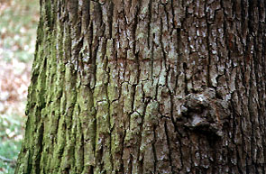

Dashefsky, Steven H. 1995. Microbiology: High School Science Fair Experiments . New York: McGraw-Hill.

1970. Collier’s Encyclopedia. Canada. Crowell & Collier Educational Corporation.

1966. Encyclopedia America. New York. American Corporation.

Rosita Arvigo and Michael Balick. 1993. Rainforest remedies: One Hundred Healing Herbs of Belize. Twin Lakes, Wisconsin. Lotus Press.

Margery and Howard Facklam. 1992. Healing Drugs: The History of Pharmacology. Oxford.
Facts On File.

Castleman, Michael. The healing Herbs, Emmaus, Pennsylvania: Rodale Press, 1991.

Chevallier, Andrew. The encyclopedia of Medical Plants, New York: DK Publishing, 1996.

Asa, Rick. “Common tree bark yields potential skin cancer cure (Online) Available http//:www.uic.edu/depts/paff/uicnews/archive/uicnews/uicnews9503/uicnews9503-22/50524025.html

Coombes, Allen J. Trees: The visual guide to more than 500 species of trees from around the world, New York: Dorling Kindersley, INC. 1992.

Collingwood, G.H and Brush, Warren D. Knowing your Trees, Washington, D.C: The American Forestery Association. 1937

