Document Analysis: What Happened at Kent State?

One of the most tragic and controversial events during the Vietnam era in the United States was the violent confrontation between the Ohio National Guard and a large group of students at Kent State University on May 4, 1970. On that day four students were killed and nine wounded. What exactly happened at Kent State, and why, will never be known with absolute certainty.
The late 1960s were a time of increasing unrest on America's college campuses. The Vietnam War spurred student political groups (like the SDS -- Students for a Democratic Society) proliferated on many campuses. Student outrage over the U.S. failure to get out of Vietnam peaked when President Richard Nixon announced, on April 30, 1970, that he ordered U.S. troops into Cambodia, thus apparently expanding the war.
The next four days were marked by escalating student unrest on the campus of Kent State University and in the town of Kent itself. On Friday, May 1, there were disorders in the city; on Saturday a group of students burned the campus ROTC building, and the authorities requested troops from the National Guard; on Sunday the first confrontations between the Guard and the students took place; on Monday, the accumulated tensions climaxed with the killings that shocked and aroused the nation.

Statement of General Robert Canterbury, Assistant Adjutant General of the Ohio National Guard, to the President's Commission on Campus Unrest, August 25, 1970. The Report of the President's Commission on Campus Unrest, 269-70.

As the troop formation reached the area of the Pagoda near Taylor Hall, the mob located on the right flank in front of Taylor Hall and in the Prentice Hall parking lot charged our right flank, throwing rocks, yelling obscenities and threats, `Kill the pigs,' `Stick the pigs.' The attitude of the crowd at this point was menacing and vicious.
The troops were being hit by rocks. I saw Major Jones hit in the stomach by a large brick, a guardsman to the right and rear of my position was hit by a large rock and fell to the ground. During this movement, practically all of the guardsmen were hit by missiles of various kinds. Guardsmen on the right flank were in serious danger of bodily harm and death as the mob continued to charge. I felt that, in view of the extreme danger to the troops at this point, that they were justified in firing.

Kent State student, Yvonne Mitchell, who, according to The New York Times, was an "average student, not greatly involved in anything, but concerned." The New York Times, 11 May 1970.

Question from Reporter: Did you think the Guard was seeking a confrontation?
Yvonne Mitchell: There's one thing that should be said here. It was noontime. And lunchtime. And a change of classes. There were people who were just curious. And there were some kids who were really just trying to go to class. And the last thing in anyone's mind was that anyone would be getting shot. That's the sad part. There weren't just kids messing with the National Guard, or radical kids, or conservative kids. There was just, like I say, an integration of everybody. I heard so many times people say, `Well, if you're straight, if you're not starting anything, they won't bother you.' Well, I'm here to tell you, they didn't care who you were. If you were in the way, you just got run down.

Testimony of Claudia Van Tyne, a 20-year-old junior at Kent State. Bill Warren, ed. The Middle of the Country: The Events of May 4th As Seen By Students and Faculty at Kent State University (June1970), 119-21

For what occurred on Kent State University's campus I can only give one term -- murder. . . . The area was filled with students in the middle, many spectators on the outskirts and the pigs were lined-up waiting. I don't like the expression "pigs" but it is the only word I shall ever use again to refer to law officials. . . . The pigs then informed us that we must disperse over their bull horn. In our response, we informed them that they, not us, should get off our campuses and we began chant `Power To The People -- Off The Pigs' etc., etc. They then began making their advance and everyone walked, telling others not to run but to walk, up the hill. We were all choking and sputtering because the tear gas (pepper pellets) had already been shot. . . . The pigs advanced, came up the hill and marched down into the old football practice field behind Taylor Hall (architecture building) where they gassed us again. Many of us picked up the cannisters and tossed them back. Finding themselves out of tear gas, the pigs retreated followed by jeers and a few rocks. I was next to the architecture building, about twenty feet away from them, when suddenly they turned and fired. I was stunned to say the least. We all were. No one expected it. . . .
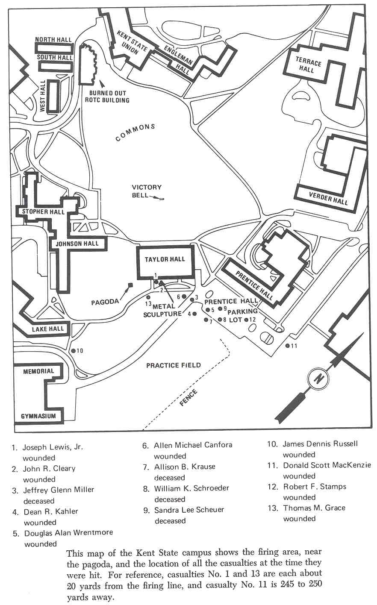
Photo Document 1

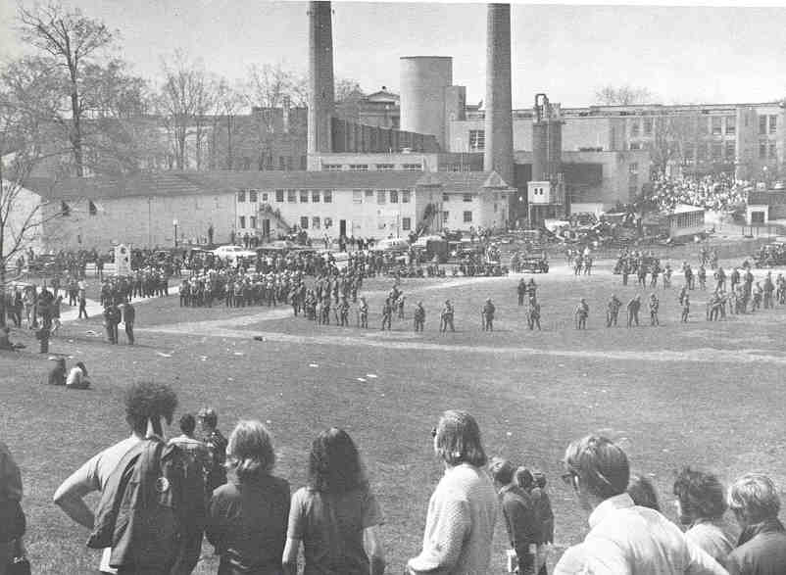
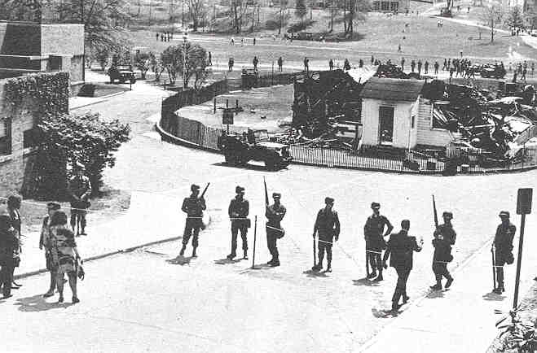
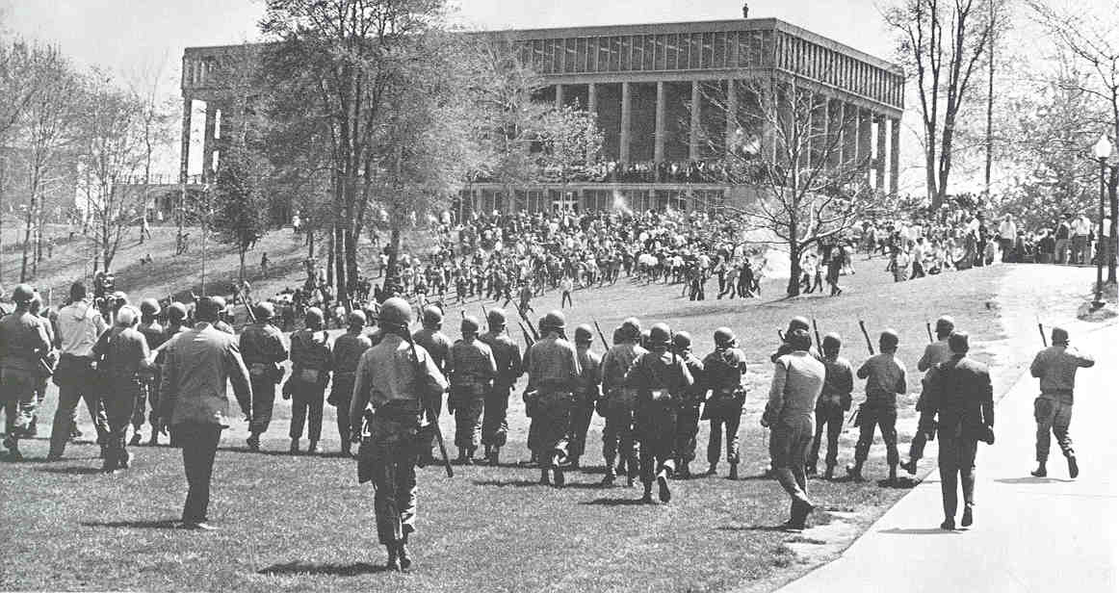
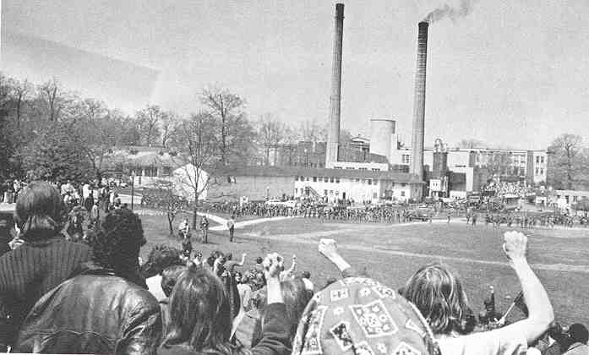
Photo Document 2

Photo Document 2
Photo Document 3
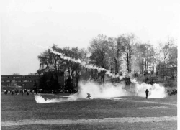
Photo Document 4
Photo Document 5
Photo Document 6

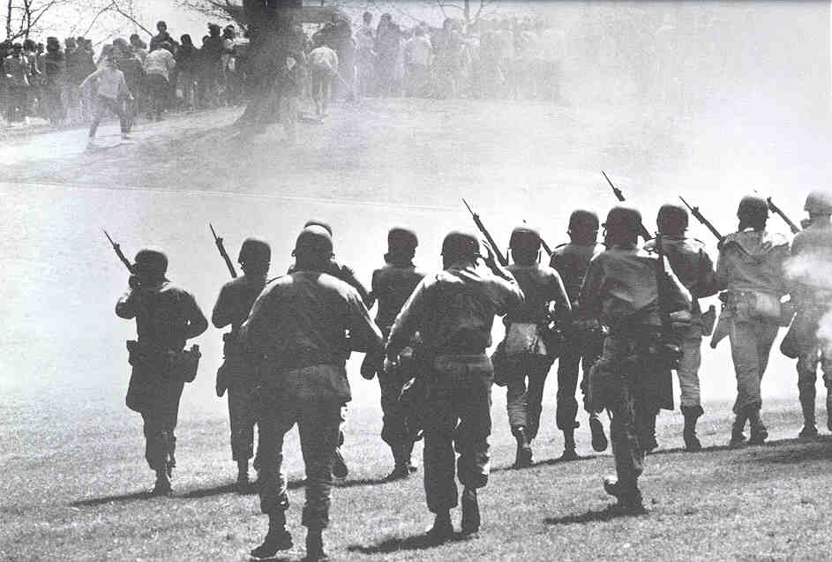
Photo Document 7

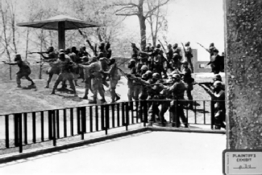
Photo Document 8
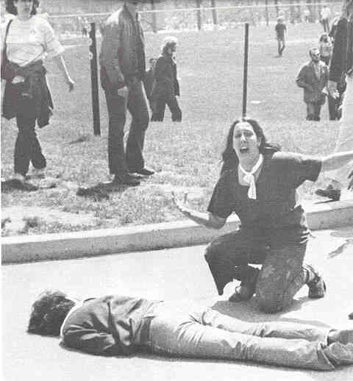
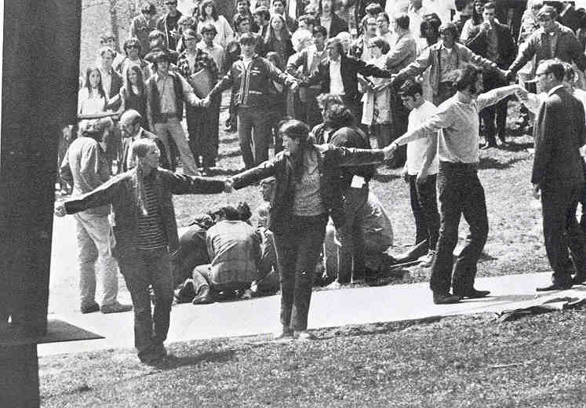
Photo Document 9
Photo Document 10
Testimony of unnamed Guardsman -- a 23 year old, married machinist. "Special Report," Akron Beacon Journal, 24 May 1970.

Q.-Did you shoot to save your life?
A.-No. I didn't feel that. Because, like it was an automatic thing. Everybody shot, so I shot. I didn't think about it. I just fired. . .
Q.-Did you feel threatened?
A.-No. I didn't think they'd try to take our rifles, not while we could use the bayonets and butts . . . . The guys have been saying that we got to get together and stick to the same story, that it was our lives or them, a matter of survival. I told them I would tell the truth and couldn't get in trouble that way.

Testimony of Richard Schreiber, assistant professor of Journalism. Shreiber had been in the army and was a life member of the National Rifle Association. James Michener, Kent State: What Happened and Why (1971), 359.

I went out on the south porch of Taylor with my binoculars and saw something which has caused a lot of discussion. While the Guard was pinned against the fence, the students kept throwing rocks, but they were rather far away and most of the rocks were falling short. I happened to have this one Guard in my glasses and I saw him raise his revolver and bang away. I've fired many hundreds of rounds with a .45 and I know a shot when I see one. There can be no question but that he fired the first round of the day. But the damnedest thing happened. Even while he was firing, some student ran up with a gas grenade and threw it at him. Where could he have possibly got it? Didn't look like the ones the Guards had been using. One of the Guardsmen, foolishly I thought, picked up the grenade and threw it back. It seemed like horseplay, so I turned away.

Report of the special grand jury that investigated the Kent State tragedy. The grand jury was composed of fifteen middle-aged local residents, and began meeting on September 14. The New York Times, 17 October 1970.

Those orders [to disperse], given by a Kent State University policeman, caused a violent reaction and the gathering quickly degenerated into a riotous mob. . .
Those who acted as participants and agitators are guilty of deliberate criminal conduct. Those who were present as cheerleaders and onlookers, while not liable for criminal acts, must morally assume a part of the responsibility for what occurred. . .
It should be made clear that we do not condone all of the activities of the National Guard on the Kent State University campus on May 4, 1970. We find, however, that those members of the National Guard who were present on the hill adjacent to Taylor Hall in May 4, 1970, fired their weapons in the honest and sincere belief and under circumstances which would have logically caused them to believe that they would suffer serious bodily injury had they not done so. They are not, therefore, subject to criminal prosecution under the laws of this state for any death or injury resulting therefrom.
It should be added, that . . . the verbal abuse directed at the guardsmen by the students during the period in question represented a level of obscenity and vulgarity which we have never before witnessed!

