Alex Beck
01/20/04

The Ultimate War Crime, committed by America Incorporated

My first feeling, when I saw 911 was that it was the beginning of a movement that had been underground for a long time, something that has been culminating by a secret organization somewhat like Fight Club. I knew in my heart this was not the work of Islamic terrorists, but something much more sinister and dangerous. I told everybody that it was not Islamic terrorists, that it would usher in something far more terrible. They could not have coordinated such an amazing feat.
That very afternoon the media knew exactly what happened and laid the official story out perfectly explained everything and accounting for everything in detail. Experts with insider knowledge of how the towers were built gave detailed accounts as to how the black smoldering smoke was actually a inferno melting all the trusses, thus causing a perfect pancaking chain reaction. I was proved wrong about my denial of the Muslim culprits. I admitted I was wrong saying “I guess they’re more powerful and ingenious than I thought.” Then I became fervently patriotic, I wore a pin, and made fun of anyone who did not want the US to invade Afghanistan, calling them “wussies who would let Hitler roll over the world.” I was also pro-war on the Iraq issue for a variety of reasons.
I did notice some peculiarities in the story we were given. For one I did not understand why the courageous passengers of flight 93 knew that they were going to die when they were simply trying to take back a plane from four men with scissors? Wouldn’t they say that they were, going to try to take the plane back, instead of we are going to bring it INTO THE GROUND!? Also, I couldn’t believe that WTC-7 fell down when there were 4 other buildings in closer proximity that it. If the buildings are so weak that one crashing down causes others around it to crash down wouldn’t the whole city go? And why did the south tower fall first by 30 minutes, when it was hit 18 minutes after the north tower was, and the plane flying into the south, missed the center of the building where the supports were, causing most of the fuel to be ejected in that infamous fireball. Seems like it should have been the other way around to me. But the seed of doubt in my mind was extinguished because I trusted that the “independent” media I watched and read were telling the truth. I believed the only organization that would be evil enough to kill so many innocents was Al-Qaeda.
But when I saw this image, I started thinking.
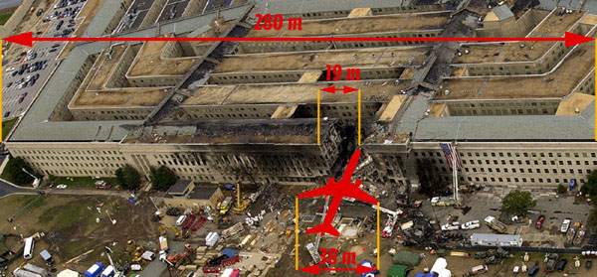
Why didn’t the wings damage the siding of the buildings, and where was the frame of the airplane? That is when the seed of doubt was reborn and I searched anew, this time not on the propaganda media we are always exposed to. I found http://www.serendipity.li/. The site claimed that it was all staged by the government, “Yeah right” I said in disbelief, but because I knew how important the invasion of Afghanistan was in securing oil interests, I read on looking for a specks of truth, to put the outrageous “conspiracy theory” to rest. What I found were these:
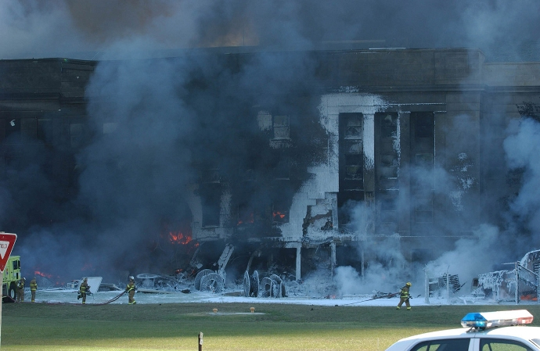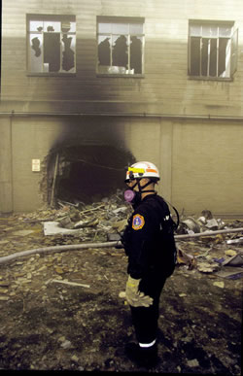
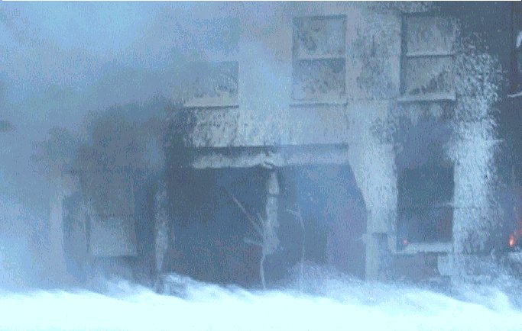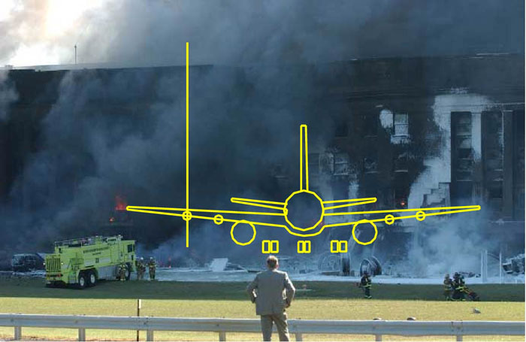 All pictures of the wall after the “plane” impacted
Surveillance camera photos from www.boston.com/news/packages/underattack/news/pentagon_image_1.htm
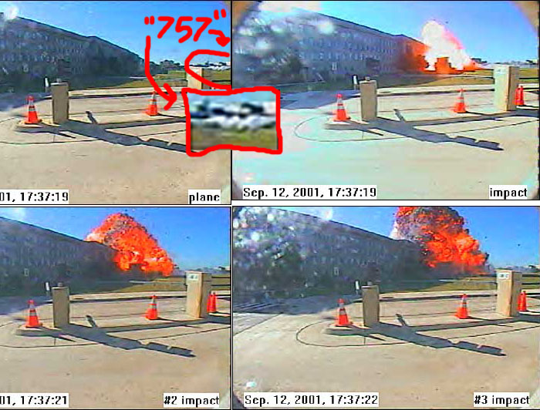
Notice the 757, oddly similar to a AGM-86C Conventional Air Launched Cruise Missile. Also note the enormous blast induced by the gasoline tanks of the 757. Oddly enough all that fuel managed to get mixed with O₂ before the impact. Looks more like a 3,000-lb PBXN-111 Blast Fragmentation Warhead, like the ones we saw in Iraq.
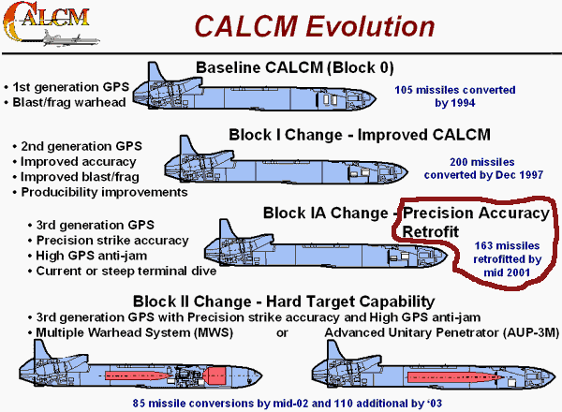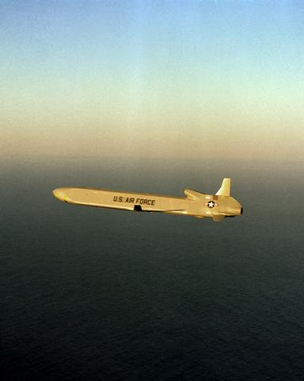
At first I thought pre-wall collapse pictures were just forgeries, but they are too far too real, the whole official story collapsed for me. I remembered what the key to nazi propaganda was all about; perpetuating a beautiful lie, and fighting and concealing the light of truth. I remembered how hard it was to melt steel given that heat is conducted across the entire body of steel, thus any heat on the superstructure of the WTC would be distributed throughout it (and being that the WTC was actually designed and built to withstand a Boeing 707, having just slightly less weight, about the same fuel, and faster top speed, it is very hard to believe both of them would have collapsed.) I remembered how hard it was to make sky scrapers fall down perfectly and normally, especially when there is a strong central steal reinforced core, which would have certainly toppled over before it pancaked at near freefall velocities. I remembered what I thought intuitively.
I recommend you to visit the site above and see how the demolitions proceeded, how the flight controllers were duped, and the passengers of the 3 other planes, after being instructed by NORAD to land at designated military bases, were herded onto flight 93 and shot down over Pennsylvania. Also see the US’s various motivations to commit the atrocity. If you don’t see the site http://www.serendipity.li/, this entire essay will sound just like fiction. Trust me, IT ISN’T!!!!
You are wondering how our republic could do that too us, well we don’t live under a republic anymore. Let’s go back to a very precarious time in our republic, the Civil War. In order to finance the Civil War both North and South took out huge foreign loans to pay conscripts and acquire armaments, the house of Rothschild held huge influence among international banks at the time, and after the war ended, the loans were so great that our nation would be plunged into a financial crisis of epic proportions. Congress was forced to do something very drastic to avert our impending bankruptcy, they were forced to make a deal with the devil. They sold out our country with the "An Act To Provide A Government for the District of Columbia," or the Act of 1871. It created a separate corporate government in the District of Columbia, bound only by roman international law (Divine Right as Kings), the corporation was called, get this: THE UNITED STATES. Notice the capital letters, legally it makes it is a totally separate entity. They also forged or changed the original constitution so it read “THE CONSTITUTION OF THE UNITED STATES” instead of the original title: “The Constitution for the United States.” Thus the government supposedly wielding civil war emergency powers, illegally hijacked the constitution of our republic and replaced it with the corporate charter exactly like it, except “of” instead of “for,” and the original 13th amendment was not included in the corporate charter:
If any citizen of the United States shall accept, claim, receive or retain any title of nobility or honour, or shall, without the consent of Congress, accept and retain any present, pension, office or emolument of any kind whatever, from any emperor, king, prince or foreign power, such person shall cease to be a citizen of the United States, and shall be incapable of holding any office of trust or profit under them, or either of them.
The historical records of the vote of Virginia was changed from accepting the amendment to a “no reply status” and most other records of Virginia’s vote were erased. Your probably wondering how a corporation secretly gained governance over us. They expanded their power through the vaguely worded “14th” amendment (and proceeding amendments):
Section. 1. All persons born or naturalized in the United States and subject to the jurisdiction thereof, are citizens of the United States and of the State wherein they reside. No State shall make or enforce any law which shall abridge the privileges or immunities of citizens of the United States; nor shall any State deprive any person of life, liberty, or property, without due process of law; nor deny to any person within its jurisdiction the equal protection of the laws.
Section. 2. Representatives shall be apportioned among the several States according to their respective numbers, counting the whole number of persons in each State, excluding Indians not taxed. But when the right to vote at any election for the choice of electors for President and Vice President of the United States, Representatives in Congress, the Executive and Judicial officers of a State, or the members of the Legislature thereof, is denied to any of the male inhabitants of such State, being twenty-one years of age, and citizens of the United States, or in any way abridged, except for participation in rebellion, or other crime, the basis of representation therein shall be reduced in the proportion which the number of such male citizens shall bear to the whole number of male citizens twenty-one years of age in such State.
Section. 3. No person shall be a Senator or Representative in Congress, or elector of President and Vice President, or hold any office, civil or military, under the United States, or under any State, who, having previously taken an oath, as a member of Congress, or as an officer of the United States, or as a member of any State legislature, or as an executive or judicial officer of any State, to support the Constitution of the United States, shall have engaged in insurrection or rebellion against the same, or given aid or comfort to the enemies thereof. But Congress may by a vote of two-thirds of each House, remove such disability.
Section. 4. The validity of the public debt of the United States, authorized by law, including debts incurred for payment of pensions and bounties for services in suppressing insurrection or rebellion, shall not be questioned. But neither the United States nor any State shall assume or pay any debt or obligation incurred in aid of insurrection or rebellion against the United States, or any claim for the loss or emancipation of any slave; but all such debts, obligations and claims shall be held illegal and void.
Section. 5. The Congress shall have power to enforce, by appropriate legislation, the provisions of this article.
This amendment was rammed through by republicans during their almost total dominance during reconstruction. Race had absolutely nothing to do with it. They slowly switched over other aspects of the government, by changing the corporate constitution and slowly replaced the seats of the old republic with the very same physical chairs of the corporation all centered within D.C. In 1933 our gold was surrendered to D.C. control, and in 1944 under The Bretton Woods Agreement, America Inc. was sold to the newly created IMF.

Thus has our nation come under pseudo-legal, indirect Illuminati/Rothschild/Freemason control. Perhaps there is a correlation to this rule and the unprecedented economic/industrial development we fared in the decades following the transition. We can do something about it however, we can reseat the old republic and demand in international courts, for them to give to the republic the gold they stole, and to be held responsible for their innumerable war crimes. The effort is already under way by Team Law, although starting up the old republic may not avert the externalization of illuminati rule, it will greatly undermine further gains they seek to secure from the complacent masses by the continuance of the illusionary war on terror. The next “911” or the one after that will cause, the passing of the Patriot Act II, the implementation of the shadow government, the activation of FEMA, the suspension of the constitution, government controlled labor, and herding of the disobedient into concentration camps.

http://www.boeing.com/defense-space/missiles/calcm/calcm_back.html
http://www.engg.ksu.edu/KSE/features/wtc.htm http://www.boeing.com/commercial/767family/pf/pf_200prod.html http://www.boeing.com/commercial/707family/product.html
http://www.thirdamendment.com/missing.html
http://www.mises.org/freemarket_detail.asp?control=282
http://www.serendipity.li/jsmill/us_corporation.htm http://www.teamlaw.org/
http://www.publicintegrity.org/dtaweb/report.asp?ReportID=502&amp;amp;L1=10&amp;amp;L2=10&amp;amp;L3=0&amp;amp;L4=0&amp;amp;L5=0 (The article) http://www.publicintegrity.org/dtaweb/downloads/Story_01_020703_Doc_1.pdf (the file)
http://www.washingtonpost.com/ac2/wp-dyn?pagename=article&node=&contentId=A20584-2002Feb28&notFound=true
http://www.abovetopsecret.com/pages/camps.html http://www.apfn.org/apfn/camps.htm http://www.freeamerican.net/ifa29.htm http://mindcontrolforums.com/camp9-97.htm, search for: “STATE OF EMERGENCY”

