Alex Beck

A dead planet. Because of salt found on the bedrock Mars once had enough water to sustain life.(Vergano) How is this important? The water that was once on the surface of Mars cannot leave the planet, so it is still somewhere, maybe deep underground, but it is there. Also this implies that there could have, at one point in time, been any amount of life on Mars, from bacteria to animals. But because of Mars’s thin atmosphere, there is certainly no life on the planet now.
Well that is the official story at least, but there is some deal of controversy surrounding that. Which of these pictures seems more real?
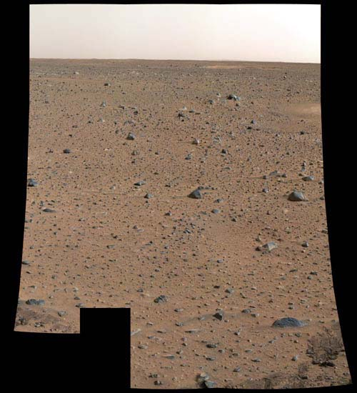
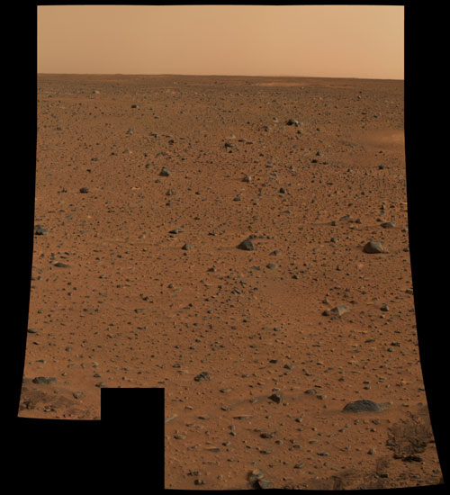
If you choose the right one, you are wrong. Well according to the officials at least. The left picture was an official NASA released picture of Mars, while the right is photoshopped up to show the true colors of Mars, or as the colors have changed in the past months?
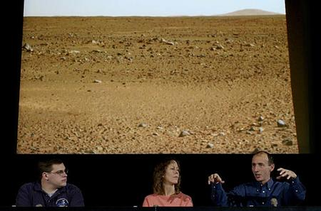
This picture was released at a news conference on January 10th and clearly shows the true color of the Martian atmosphere. Another picture taken of the Tetrahedral landing platform shows the doctored image. A close up of the blue logo demonstrates the “true color’s” modification.
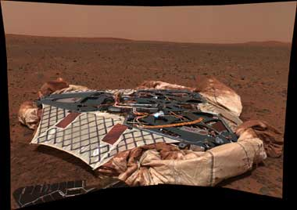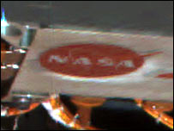
However a BBC article explains this occurrence; “Colours in the image have been adjusted but scientists have not yet determined the "true" colour of the Martian rocks…
Nasa scientists have used the colour calibration target, also known as the sundial, to adjust the image so that its hue is a close approximation of the colour of the Martian surface…
However, mission scientists will have to perform further calculations before they can produce an image that shows Mars' "true" colour.”
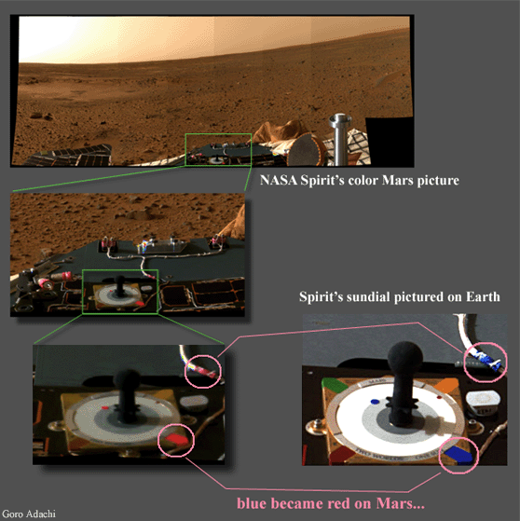
Interestingly enough, cell phones are being sold which are equipped with 1.3 mega pixel cameras which can decipher “true color” perfectly; however, the “greatest minds” in the world cannot put a working color camera on a multi-million dollar interplanetary rover. Here’s a comparison of the sundial on Earth and on Mars, obviously the spectra changes depending on what planet you are on.
What is NASA hiding about Mars? Perhaps life, perhaps just the fact that it has a high enough atmospheric pressure that your eyes won’t pop out like Arnold Swarzinager’s in Total Recall. Personally I think the atmosphere is breathable or at least partially breathable. Perhaps the US is trying to hide Mars’ inhabitability to inhibit other nations colonization initiatives. Another words NASA is hiding the viability of surface colonization so that we win the space race. However there is know way to know this either way, given that public data is doctored.
Mainly this revelation brings up the obvious question; what else are they concealing from us. Only a small amount of pictures get released to the public and many not immediately after, many of these photos are in black and white and even more only a “subjective” interpretation of “true color.” Perhaps there really is life on Mars as we speak, or remnants of an older civilization long deceased.
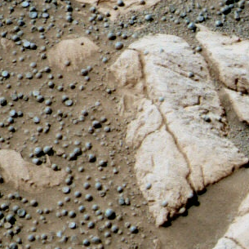

Note sundials above are there so you can judge for yourself the correctness of the color calibration settings used to recalibrate colors on the above left picture.
These little stones called blueberries provide rock hard evidence of the existence of water.(MSNBC) These spheres are packed with hematite, a mineral that requires at least some water to form. Whether of not they formed from ground water or standing water is still a mystery, but one thing is for sure water is in mars and was once on its surface.
However one interesting thing to note from the MSNBC article is “the blueberries --- are, for the record, gray in color.” Why make such a strong point, got something to hide? The correctly calibrated color clearly shows them to be light blue, the exact color of this text, above left. Maybe I should email MSNBC and tell them that just because a picture is black, white, and gray, above right, that doesn’t mean the objects observed are black, white, and gray. They are called blueberries for a reason. The rest of the media and sometimes NASA still gives out gray photos even though we are in the 21st century. Either that or these little pellets are something else, like built of an organic material, or some other living or artificial thingamajig or byproduct. We will never know as long as NASA feeds us Black and White images, color images tinted red, and whatever tidbits they allow us to see, modifying/censoring from us anything they please.
Works Cited

“‘Blueberries’ shed light on Mars’ history”. March 19, 2004. MSNBC. <http://www.msnbc.msn.com/id/4564817/>

“Rover's stunning image of lander.” January 21, 2004. BBC News. <http://news.bbc.co.uk/2/hi/science/nature/3418147.stm>.

Vergano, Dan. “Mars rover finds evidence of ancient water.” March 3, 2004. USA Today.

<http://www.keithlaney.com/>.

