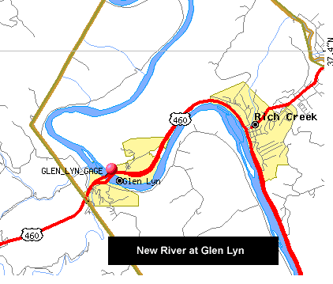
Data Files
“A River Runs Through It.” Going with the Flow of the New River at Glen Lyn, VA, from the comfort of B030.
The file New_River_Data.xls is an Excel file obtained directly from the US Geological Survey (www.usgs.gov). This file contains data on the discharge (measured in cubic feet per second) of the New River at Glen Lyn, VA (cite # USGS 03176500) and a link to this Excel file is provided at our programming assignment website. Discharge data is taken every 15 minutes for a 31 day period. The data in the Excel file begins on October 4, 2004 at 0:00 hours and goes through November 4, 2004 at 10:00 hours. For our river data, the x-coordinate will be the number of hours since October 4, 2004 at 0:00, and the y-coordinate is the corresponding flow rate (volume of water passing a point per second) at that time, measured in ft³/sec. You should open this file (with Excel) and take a look at it.

Part 1

Figure out a manner to enter this data (y-values) into a one-dimensional array in your program. One-way is to brute force it, by typing in all n discharge data values (what is n?!). A second, and much more accurate and efficient way, is to READ it into your program. Below is a silly sample program that may help you with the latter, so you may want to figure out what it is doing. Below, the total number of “y-values” is in the first entry in the input file. This is not the case for your input file.

PROGRAM how_to_read
!Demonstrates basic format for reading data in from a file

IMPLICIT NONE
INTEGER :: i=1, n
REAL(KIND=8), DIMENSION(:), ALLOCATABLE :: seq_in, seq_out

OPEN(3,FILE='trial_in.dat',STATUS='UNKNOWN')
READ(3,*) n
WRITE(*,*) 'n=', n
ALLOCATE (seq_in(n), seq_out(n))

DO
READ (3,*) seq_in(i)
WRITE(*,*) i, seq_in(i)
IF (i==n) EXIT
i=i+1
END DO

CLOSE (3)

seq_out=2.0*seq_in

OPEN (2,FILE='trial_out.dat',STATUS='REPLACE')
WRITE (2,*) n
DO i = 1,n
WRITE (2,*) seq_in(i), seq_out(i)
END DO
CLOSE (2)

DEALLOCATE (seq_in, seq_out)

STOP
END PROGRAM how_to_read

On the next page is a look at sample input and output from the sample program.
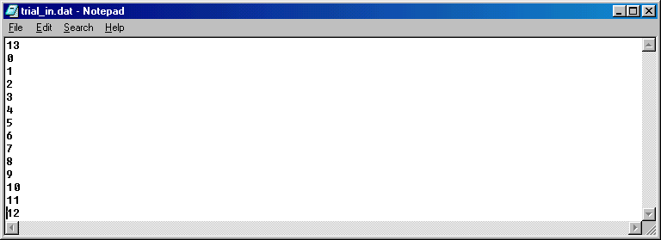
To make it a little easier on you (aren’t I so kind), I have put a data file corresponding to our river data up on the web in a nice form for you. For your convenience, the file New_River_Discharge_Data.dat contains only the discharge data, no times, words, etc. as in the Excel file, and so will be easier to read into your program. It pays to read the small print. (If you want to see the data, one way to look at it is to open it in Notepad).
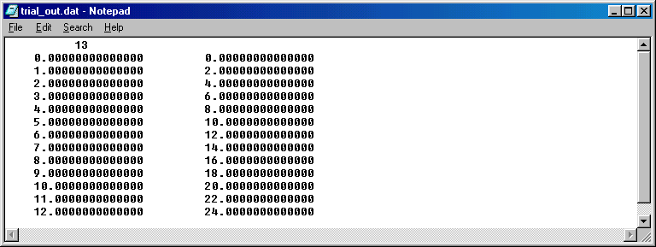

Part 2
Construct a program, which will prompt the user to input a real number in the appropriate range for our data set. The program should tell the user the date and time (to the second) that this number corresponds to within the time period of the data. For example, an input of 0 corresponds to October 4, 2004 0:00:00, an input of 0.5 corresponds to October 4, 2004 0:30, and input of 0.125 corresponds to October 4, 2004 0:07:30. (Note that since our x-axis is measured in hours, for our data h=???) The main goal here is to attain an approximation of the discharge at the input time. The program should choose the closest quarter hour to the input and build from this data point, if possible, 6th degree forward, backward, and centered Newton Interpolating Polynomials using divided differences. Allow the user to request which of the 3 types of interpolating polynomial approximations they would like at their input value, and inform them if they choose one that is not possible. The program should evaluate the corresponding 6th degree polynomial from the user’s request to approximate the discharge at the input time and return this value to the user in an informative output statement. Since you will use the divided difference algorithm to determine your coefficients it might be useful to store the values in a two-dimensional array (but you don’t have to—see Lab #9 for some 2-D array programs/discussions). Determine the approximate discharge for several different times, which include screen shots showing approximations for input of 0.7, 25.1, 242.65, 11:52 PM on Halloween night, and five minutes before the end of the data set.

Part 3
Construct a program that will use five-point differentiation method(s) to approximate the derivative of the discharge (measured in ft³/sec) with respect to time (measured in hours) at each quarter hour from October 4, 2004 0:00 to November 4, 2004 10:00. The user should be able to enter a real number as in Part 2, and the program should check that the input time actually corresponds to a particular “x-value” of the data. If so, the program should return the approximate derivative of the discharge for that day and time using the best five-point formula possible for each approximation. Note that our flow rate data has equally spaced time intervals of hours. Determine the approximate derivative of the flow for several times. Include screen shots to demonstrate your error checking for appropriate input and for the derivative computation at the following input: 0, 23.75, 263.75, 412.5, 531.5, and November 4 at both 9:00 and 10:00 am. Write an appropriate and informative message to the user regarding the value of the derivative at the date and time corresponding to the real number input. Include units and an interpretation of what the approximation means.

Part 4
Construct a program that will use Simpson’s rule as given on page 384 in Applied Numerical Analysis, to approximate the integral of the discharge between any two data points for which an even number of subdivisions of the data is possible for our given h. The user should be prompted to enter a real number corresponding to a particular date and time, then be prompted to enter a second later date/time real number and be sent an error message if the input is not compatible with the above criterion. The program should return the approximation to the integral of the discharge between these two inputs. Write an appropriate and informative message to the user regarding the value of the integral between the two dates/times corresponding to the real number input. Include units and an interpretation of what the approximation means. Include screen shots showing the approximation to the value of the integral or error messages where appropriate, for the input
(0 to 1), (0 to 24), (110.5 to 182.75), and (242.75 to 621.25), as well as for input corresponding to our class time on Election Day, the portion of the month of October included in the data set, the portion of the month of November included in the data set, and the entire time period covered by the data set. This time for your final output, convert so that your final answer has units of ft³ only.

Special Instructions
This programming assignment will NOT follow the guidelines established in the syllabus. In particular, there will be NO OFFICIAL WRITEUP for this assignment. Your programming assignment should ONLY include the following in the following order:
- Title page, with name, date, and signature.
- Copy of WELL-DOCUMENTED program (!!!!lots of comments, good variable names, header blocks for program and subprograms, etc….!!!!)
- Screen Shots—LABELED!!
- Extra Credit, if any, LABELED and ORGANIZED (or I WON’T read it, i.e., NO CREDIT!!)
- Honor pledge + acknowledgements of help, if any, and signature.
- Labeled floppy disk with .f90 and .exe files as well as any other needed files, attached in some convenient way that will not get lost!

Grading Notes
This time you are on your own! No groups. Just you and the computer.

Assigned: Wednesday, November 17 2004

Due: Thursday, December 9 2004 by 2:00 PM

Grading will be out of 100 points as follows:
40 points: Part 1 (10) + general programming style (20) and final document style (10).
60 points: Any TWO of Parts 2, 3, or 4 (30 points each).
30 points Extra Credit: Add the remaining Part not done above.
(So doing Parts 2, 3, and 4 =>130 possible points out of 100!).

20% EXTRA Extra Credit:
- Give a comprehensive discussion of the error in each of Parts 2, 3, and 4 and some idea of the amount of accuracy you might expect in the approximations. Discuss in general for all Parts and for particular representative examples as appropriate for each case in at least two of Parts 2, 3, and 4.
- Edit your program so that it performs a Simpson’s Rule numerical integration scheme whenever the integer input data corresponding to the time interval is appropriate for this rule, and demonstrate with screen shots for all sets of input data from Part 4 that are appropriate for this method. Also, comment on how you could attempt to implement the first Simpson’s method discussed in class for this data (don’t do it) and on the differences between this method and the one you programmed in Part 4. Comment on the error for each of these three Simpson’s methods, and discuss expected accuracy in approximations employing each of these three numerical integration methods. Use examples as appropriate.

- Write a Fortran program to create the largest degree polynomial interpolant possible from our data set. This may or may not be able to be done in Fortran to include every data point; if not, create the largest degree one you can. Use this to approximate discharge and (provide screen shots for) any appropriate input from Part 2. Also, use Maple to create the largest degree interpolating polynomial you can for our data set, and then plot this polynomial in Maple. Evaluate this polynomial in Maple for any appropriate input from Part 2. Finally, also use Maple to plot the highest degree polynomial you were able to code in Fortran. Discuss any discrepancies/difficulties/etc.., if any, and include your Maple worksheet.

- Derive, in your own handwriting, the 5-pt forward, backward, and centered numerical differentiation approximations and error bounds. Also, derive the Trapezoid numerical integration approximation and error bound. Be clear and complete and do not skip steps.

(5% each part; you may do any, all, or none☺ )
So each EXTRA Extra Credit portion A)—D) is then worth 5 total points. So a total of 150 out of 100 is possible!!

