By: Alex Beck, Derek Cole, and James Kim

Honor Code: x_____________ x_____________ x_____________

The problem is that computers do not magically know how to compute basic arithmetic including addition. There has to be specially designed circuitry to add integers. First all integers in a calculation must be broken down into base 2 representations so they can be represented by low(0) and high(1) voltages by TTL circuitry (transistor-transistor logic) and/or RTL (resistor-transistor logic). In order to simulate this hardware environment we will be representing the integers in a compilation of two to three Boolean values and implementing the addition utilizing only Boolean logical statements in Fortran 90.

Pertinent information given to us in order to solve this problem includes abstract symbolic Boolean representation of the logical statements required to construct the calculating body of the Fortran program. This must be translated into Fortran 90 code along with all peripheral code.

The solution to the problem of adding is the vital initial component of all arithmetic calculations. Thus adding circuitry practically form the smallest calculating cells required to build any digital computer system. Thus if this logical operation was not understood there would be no computers in the world. If there were no computers the world would fall into total chaos as all monetary/transportation/military/PC/ Utilities/factory control systems immediately stopped functioning due to lack of adding capabilities at the cellular level. Total economic depression would ensue and the world markets would entirely collapse as all monetary systems fail and the artificial value of all world currencies vanish. Then seeking world domination the Chinese governments would conscript all it’s eligible male citizens and begin to form an Islamic/indo-Asian/Russian/Chinese alliance that would entirely take advantage of their tactical advantage of the United States’ now nonfunctional digital weapons/digital communication systems. Our military forces would be swamped with swarms of Mig fighters as we rush to retrograde our latest fly by wire fighter jets with analogue steering and missile systems. Our analogue fighter jets would be outnumbered 3:1. The massive force of the Red army would entirely wipe out our fleet (soon to be running on JAVA) and have already broken the backbone of the US military by the time we adapt to using analogue systems. ICBMs would not work and we would resort to deploying thermonuclear weapons on the Chinese via B-52 bombers, which would fail due to their massive aerial superiority. However due to inadequacies in both our radar systems enough weapons would be deployed to destroy most axial cities. One by one the nations of the world would fall under Chinese hegemony. Thus the primary impact of Binary adders on those that would survive the riots, famines, and thermonuclear/conventional war, would be that we would have to learn Mandarin Chinese, which would totally suck due to the complexity and subtle nuances of the language, also it would really suck because there would not only be no computer games but no console games either ☹.

In order to convert the integers imputed by the user using the write and read functions respectively, the MOD( ) function is used to ascertain the value of each digit. A series of if-then statements are used to attach proper values to the Boolean representations of the binary digits. This process is nested within a do loop in order to assure that the user does not input non-binary digits.

Once the Boolean representations of the binary digits of both input values are stored, the logical statement was then constructed based upon the chart given in the project assignment.

After the logical statement properly assess the values of the resultant 0-3 digit number, the final number is then reconstituted from it’s Boolean elements using a certain integer addition following a .TRUE. value within the ( ) of the if then statement. The value is then displayed to the user via a write statement.

A)
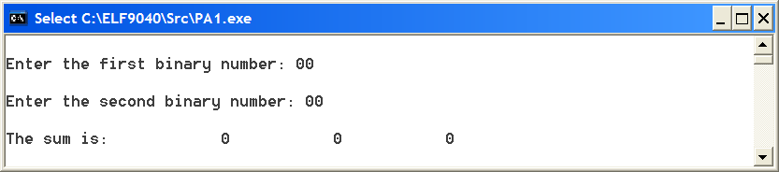
B)
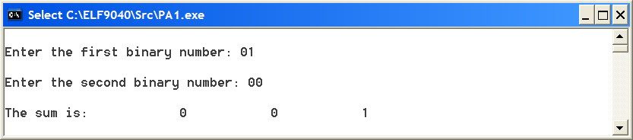
C)
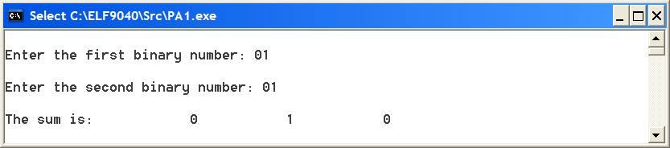

D)
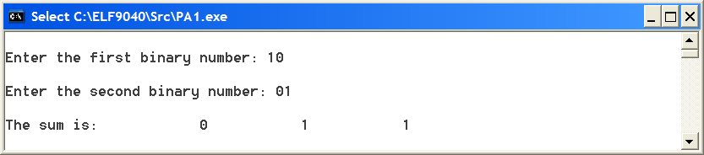
E)
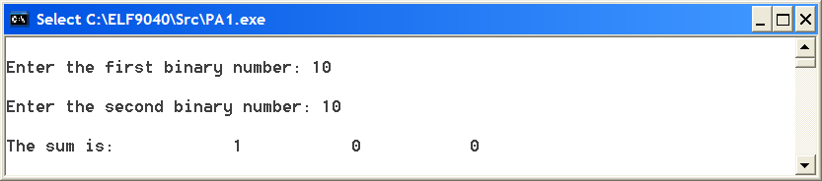
F)
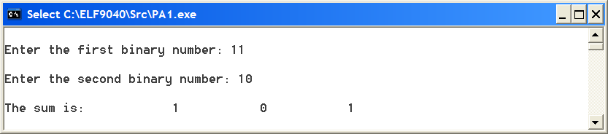
G)
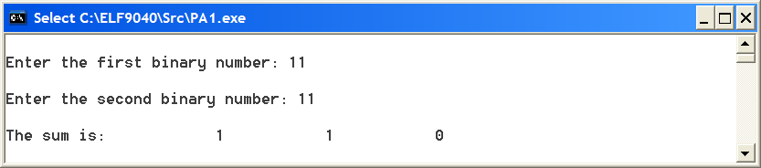

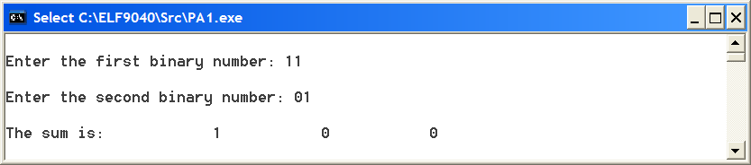This last screenshot shows two different numbers other than those from A – G being added.

