Phys. 337, Solid State Physics
HW #1
Due Weds., Jan. 17

1. Consider the following pattern in which the symbols represent different atoms:

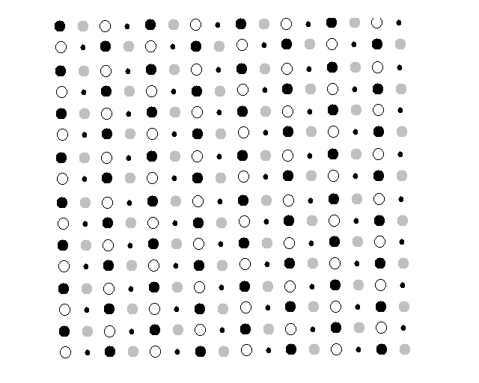
Indicate
(a) a possible set of primitive translation vectors
(b) the basis associated with each lattice point
(c) a rectangular conventional unit cell (repeatable on a rectangular network)
(d) Express the location of each atom in the basis according to multiples of the primitive translation vectors from part (a) (i.e. give r_{j} = x_{j} $\vec{a}$ + y_{j} $\vec{b}$ for each atom j in the basis where x_{j} and y_{j} are between 0 and 1)

2. (a) In 2D, solid disks of diameter D can pack most densely in a hexagonal lattice. What is the packing fraction of the disks (area covered by disks divided by total area)?
(b) The packing fraction of an fcc lattice (e.g. the lattice copper forms) in 3D is 0.7405. The nearest neighbor distance for copper is 2.56 angstroms and a typical atom has a mass of 63 amu. What is the density of copper?

3. Imagine a Cartesian coordinate system indexed by integers n_{x}, n_{y}, and n_{z}.
(a) If there is a lattice point wherever all the indices are odd, what lattice is formed?
(b) If there is a lattice point wherever the sum of the indices is even (n_{x} + n_{y} + n_{z} = even), what lattice is formed?

4. A bcc crystal has primitive translation vectors (in angstroms) $\vec{a}$ = 3i, $\vec{b}$ = 3j, $\vec{c}$ = 1.5(i + j + k).
(a) What is the volume of the primitive cell?
(b) What are the Miller indices of the plane most densely populated with atoms (i.e. closest interatomic spacing or nearest neighbor distance)?

5. Why is it only possible to have lattices with rotational symmetries of 0, 60, 90, 120, and 180 degrees? Why not 45 degrees for instance?
Starting with a lattice with two primitive lattice vectors of length a separated by some angle φ that we assume is also a rotational symmetry:
a₂

φ
a₁

All of the points of the lattice are reachable by combinations of these vectors. Now rotating clockwise by the assumed rotational symmetry:

a₂’ = a₁

a₁’ = a₃

a₂ rotates to become a₁ and a₁ rotates to become a new vector, a₃. For this to be a true rotational symmetry, we have to be able to reach all the same lattice points still. Using combinations of a₁ and a₃, what is required in order to reach the lattice point that was originally at the end of a₂ (the dot)? [There is a constraint on φ that must be met.] What rotational symmetry angles are allowed based on your answer?

