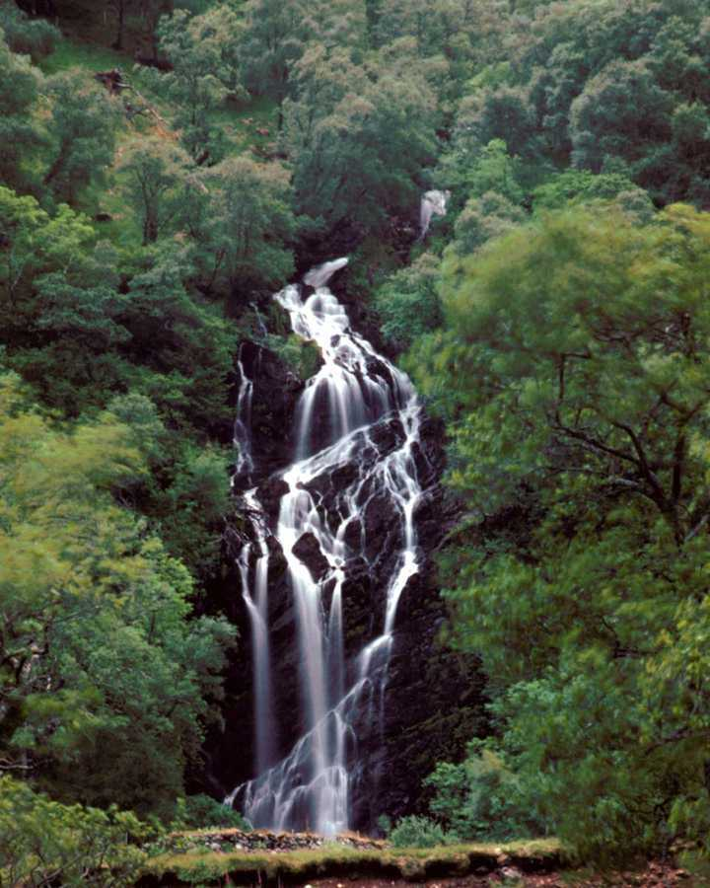

San Jose, Costa Rica

Mt. Volcan Arena

Monteverde Cloud Forest Reserve

Endangered golden toad

Population
Estimated population is 3.3 million. The Population is primarily Whites and Mestizo with a small Black Jamaican community.

Capital
San Jose in the center of Costa Rica.

Religion
95% Roman Catholic; 5% other, mainly native Indian religion.

Size

Approximately 19,600 square miles.
Slightly smaller than West Virginia.

Economy
Coffee, bananas, sugar, and cocoa are exported to other countries.
Other goods made or grown in Costa Rica include maize, rice, beans, tobacco, potatoes, livestock, and other fruits and vegetables.
Gold and silver are mined in Costa Rica.
Tourism is important to their economy.
Basically the goods imported are machinery and electronics.

Climate
Average temperature 80 degrees Fahrenheit.
100 inches of rain per year.
Humid tropical environment on the coastal plains to temperate in the interior highlands. Their rainy season lasts from April or May to December.

Language
Spanish is the main language and English is taught in schools.

Education
One of the highest literacy rates in Latin America: 95%
Primary and secondary public schools are free.

Recreation
Basic sports besides ice hockey, mainly soccer.

Geographical features
Heavily forested rolling hills, volcanic mountains, and lowland full of tropical flora.

Health
The life expectancy of 75 years is one of the highest in Latin America.
Infant mortality rate: 13/1000.

Government
Three-branch government system (Legislative branch made up of 57 deputies, Judicial branch made up of Supreme Court, and Executive branch made up of the president of Costa Rica, Jose Maria.)
One republic Constitution still in effect today.
Colones are the monetary unit of Costa Rica, consisting of 100 centimos. (85.71 colones equal 1 US dollar, 1990).

Additional interesting information
- More than 32 % of Costa Rica’s land is in parks, refuges, biological reserves, forest reserves, protected zones and Indian reserves.
- The largest ant in Costa Rica is the “bala,” which measures 1” in length and has a powerful sting.
- Canopy tours allow tourists to observe the upper reaches of the rain forest.

Bibliography
National Geographic magazine
The World Fact Book
Costa Rica, a Natural Destination by Ree Strange Sheck

