For Chapter Eight, the class was given a take home test on stoichiometric equations. The basic model is mass to mass, with other equations in between. Then came density equations, limiting reactant, percent yield and using percent yield equations. Many equations and complex problems were involved.

♠The stoichiometric equation calculates mass and quantity relationships among reactants and products in a chemical reaction.
♠The molar masses of the substances are generally required.
♠The excess reactant is that which is not used up in a reaction.
♠The limiting reactant is consumed before completion of the reaction.
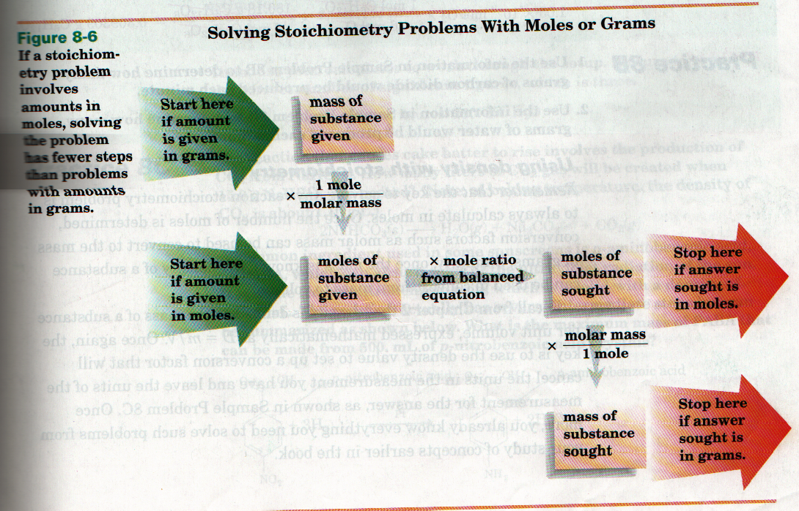

EX. N (g) + 3H (g) 2NH (g)

EX. Sn(s) + 2HF(g) SnF (s) + H

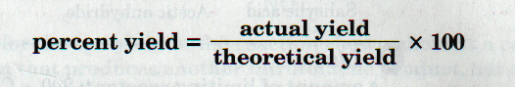
I have learned from this how to use stoichiometry to find out how to change and manipulate the values of atoms and ions. This can be applied to many modern situations including car design, engine efficiency and pollution control etc.

