Alex Beck
Period 5
2/15/03
What is a frog?
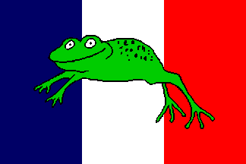
A frog is an amphibian that is smooth-skinned, web-footed, tailless, agile, has a semi-permeable skin, has three developmental stages, and usually lives in marshes or wetlands. Well that is one definition, but there is another.
To me a frog is somebody that considers cow brains a delicacy, eats steak that is barely cooked, and likes meals that are seven courses long while consisting of only a few bites of food. A frog considers it acceptable to charge somebody to use a bathroom, doesn't mind if there is no seat on a toilet, and is perfectly used to unisex bathrooms. A frog calls soccer, “futbol,” and thinks that watching it is fun. A frog hates a country that their country helped to create, and saved Frogland three times in the last century. A frog could like “Amerecen hip-hOp” but hate Americans more than anything else, while considering Sadam Hussein “not so bad”. Frogs just 70 years ago said the same thing about a an evil dictator just months before he invaded them. And before this man invaded, the frogs built a defense along their entire eastern border and left a completely unguarded hole just because “an army can’t move through the Rubicund Forest.” And less than 25 years before that they built a wall along their entire eastern border. A hole was left in this wall, that the same country invaded through. And after these wars, when they condemn their unsafe bunkers, instead of tearing them down, all they do is fill the entrance in with concrete, and pull off some of the barb wire. And they left it standing there to this day with live ammunition in it without even putting a sign up in warning.
And now Frogland and their former enemy turned ally are holding out, to appease the next evil, most probably because they want to be restored to their former power. Frogs always believe a peaceful solution is possible, and just as they have done before in the past, will wait for a peaceful solution until the world will be amidst a catastrophe, and then it will be too late and the damage will already be done.

