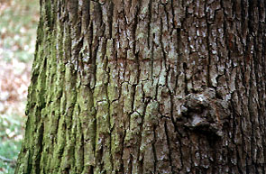

I like trees. They are complex, lush beautiful and essential for our survival. But I have wondered of late, how do trees survive? What prevents them from getting microscopic diseases. Humans and almost all animals have an immune system to fight off bacterial infections. But how do the organisms that keep us alive keep themselves alive? The bark, is certainly, by itself not enough to keep out tiny foreign particles, so how does it keep bacteria from devouring the tree. That would make a good science project, if I knew how to set it up and see it through. So, I went to the library to search for more information on the topic and found a project design plan for almost exactly what I had in mind.

