In this activity we answered questions relating to the Introductory Chapter of the book and the classification of things as in acids/bases, organic/inorganic and how synthetics and chemicals play a large role in our life. We also learned about Material Safety Data Sheets (MSDS) and its role in forewarning chemists and laboratory workers of potential chemical hazards.

♥An acid has a pH below 7. A base has a pH above 7.
♥Litmus paper is used to read the pH of a variety of substances.
♥Two other groups that regulate chemicals are the FDA and EPA.
♥Organic compounds are covalently bonded and contain carbon.
♥Inorganic compounds are those outside the organic family.

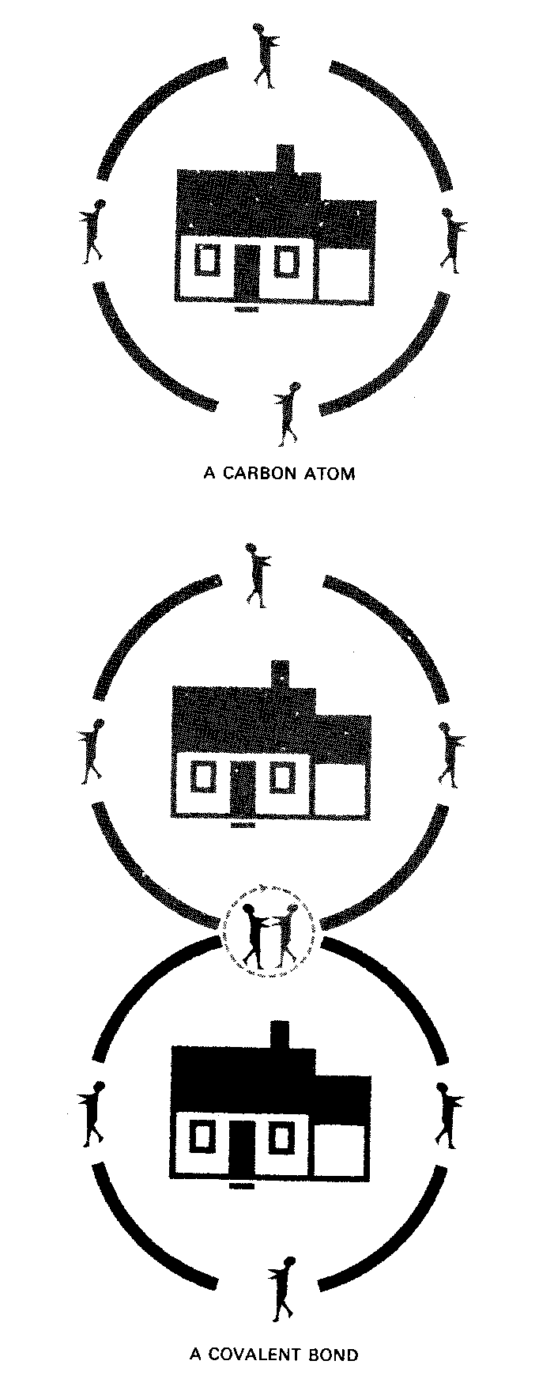

SO + H O H SO

Sulfur trioxide is converted to sulfuric acid by
adding water.

This assignment provided a basis for understanding acids, bases and the difference between organic and inorganic compounds. It also gave me a better understanding of how chemicals affect our lives and the government regulates the chemical industry.

