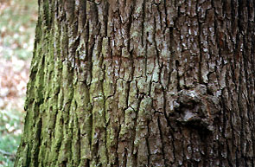

I like trees. They are complex, lush, beautiful and essential for our survival. But I have wondered of late, how do trees survive? What prevents them from getting bacterial and viral diseases. Humans and almost all animals have an immune system to fight off bacterial infections. But how do the organisms that keep us alive keep themselves alive? The bark, is certainly, by itself not enough to keep out these tiny foreign invaders. So how does it keep bacteria from devouring the tree? Could there be chemicals or other substances that kills the bacteria and viruses? Or is it a combination of many things working together in a complex process to protect the tree. That would make a good science project, if I knew how to set it up and see it through. I didn’t know how you could discover if the bark protected against bacterial infections or how this was accomplished. What bacteria would I use? What kind of bark should I include and how much? How would I know if the bark inhibited bacterial growth? The library provided answers to some of these topics. I found a project design plan for almost exactly what I had in mind. It explored the topic in a simple, straightforward manner, and was perfect for this project.

