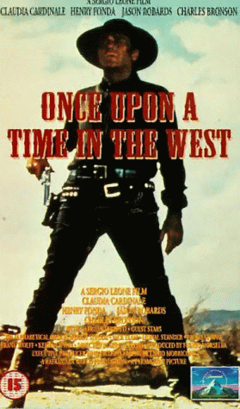
Justin Beck
3rd Film Studies
11/17/00’

Once Upon A Time In The West
Sergio Leone
1968

The landscape was that of western Arizona, near flagstaff, according to the plot. The land was flat except for large buttes that jutted out of the earth to sharp plateaus on top, mostly reddish in hue. There were the archetypal long pan shots with the soundtrack waxing melodramatic. The early scenes in the book make good use of diagetic sound to give the viewer an idea of the weird conditions and disconcerted states that the people are in, whether bandit or settler. When the bandits take a train station, locking the old watchman in a closet, they seem inured to the whining of a windmill, or the drip of water into a man’s hat, and one man sits patiently while a fly peruses his face. Later, when the McBain family (excepting Jill McBain) is relaxing on their farmhouse west of Flagstaff, they hear the insects, formerly so loud, go dead quiet. A flock of quails begins flying madly away and then they are rapidly put down, where they are standing approximately. The sound, or lack of, is used in this movie for expressionistic purposes, specifically in the eerie silences that go along with intense, dramatic scenes.

There is an archetypal crazy character, who is packaged just so that people think he is loony. The man, or harmonica, so named because instead of speaking, he belts out an eerie, repetitious tune on his harmonica. He helps in the killing of the family, but later ensures Jill’s livelihood by killing her would-be assassins. And of course he does talk, mostly to her and helps save another man’s life, who was also to be killed later. The Man defies a lot of our typical western characters, showing both a cold, weird, psychopathic side, and a somewhat warm, and compassionate one on the other hand.

The technique of this film is classically western, with long takes and fast, reaction shooting during gun battles. There are the extreme close-ups on the eyes, which is not a classical western feature. The soundtrack is classical, and the dramatic song throughout, played during vista shots, is reminiscent of a like scene in Gone With The Wind. Another interesting parallel is to the Rose Bud of Citizen Kane. Jill is distraught after coming back to their ranch and finding her family dead. She is rustling through old junk and comes upon a model house that has a sign on it “STATION.” This was Mr. McBain’s dream to make a town around their house, because it had a strategic importance for the railroad, and that was water under the land. This vision is later fulfilled in the movie, with Jill deciding to stay after pondering moving back to her home in the east, New Orleans.

