Representative Alexander Beck
Pennsylvania Congressional District 10

Dear Constituents,

Greetings! I hope that you and your families have enjoyed a prosperous year. In the first session of the 106th Congress, representatives reviewed 63 Bills. Nineteen bills passed the House Of Representatives. These bills covered many different issues, including several important ethical issues. All this was done efficiently over a very short time considering all the bills that were reviewed.

I serve on the Committee on Health and Human Issues. We examined 18 bills. Of these, only 3 were passed. All the bills that have gotten out of our committee have unfortunately failed in the full Congress. These bills are H.R. 134, the Abortion Without Parental Involvement Act, H.R. 56, The Silent Scream For Abortion Act, and H.R. 111, The Death with Dignity Act. I voted in favor of each of these bills. For each of the 18 bills presented to the Committee on Health and Human Issues, the Representative who sponsored the bill gave a 1-2 minute speech. After all the speeches were given the committee members voted on all 18 of the bills. Not all the bills were of high quality, and many presented significant technical difficulties and thus I voted against them. The speech made in favor of H.R. 56 by Ms. Hillebrand was very touching and convincing which is probably why this committee passed her bill instead of other bills banning abortions.

Most Representatives lacked the ability to make proper decisions on the structure of certain bills. For instance, the Victims’ Rights Act, H.R. 39, cost 50 million dollars and all it proposed to do was inform victims of the addresses of convicted felons. In spite of these limitations, this bill passed the House of Representatives. A bill that I presented and had high hopes for called the Using Foreign Aid Dollars for Birth Control Act, H.R. 90, failed to pass in the House of Representatives with a vote of 82 in favor, 102 opposed, and 18 abstentions. H.R. 55, Against Homosexuals Adopting Kids Act, passed in the House. I voted in favor of this bill because it presented very good points about the psychological confusion for children with two same sex parents. H.R. 77, The Changed Rules on Diplomatic Immunity Act, was passed in the House. This bill eliminated diplomatic immunity for diplomats working and living in the US. I voted against this bill because if we eliminate their diplomatic immunity, they will counter by eliminating US diplomatic immunity in other countries. H.R. 17, Saving American Wetlands Act, passed by a large margin. I voted in opposition to this bill, not because I am against preservation of our natural resources and environment, but because American Wetlands are immune to small amounts of garbage because wetlands are based on the decomposition of nutrients. Thus garbage found in the wetlands would have minimal ill effects on the wetlands and also because the bill failed to meet the usual standards. The bill to save American wetlands is unimportant because there are few wetlands in the 10th district of Pennsylvania.

In the next Session of Congress I intend to introduce legislation in several areas. These include foreign aid, health care, and crime prevention. I hope that we have additional time to present and discuss these vital issues in the upcoming session. I also encourage you to contact me regarding your views and ideas on issues affecting your lives. I am always available to meet with you and discuss important problems facing our state and great nation.

Inhalants are becoming major problems to the people of Pennsylvania. For instance over 240 people have died from sniffing inhalants since 1996. I will try to do whatever is in my power to educate our children about the dangers and risks of inhalants. The many factory workers in Pennsylvania are losing their jobs because of lack of business opportunities. I will try to solve this problem by attracting new businesses to Pennsylvania.

A large amount of tax money is considered surplus and in my opinion some of it is being used for hollow causes. Funding towards the national debt and more social security spending are wonderful ways to use our Tax Surplus. But I believe that Education and public safety are the most important things to use surplus on. By the end of this March, 36,185 people will be taken off welfare unless they work more than 20 hours a week. I am giving my full support to this program so that people dependent on welfare may gradually lose their dependency upon it.

Sincerely,

Representative Alex Beck

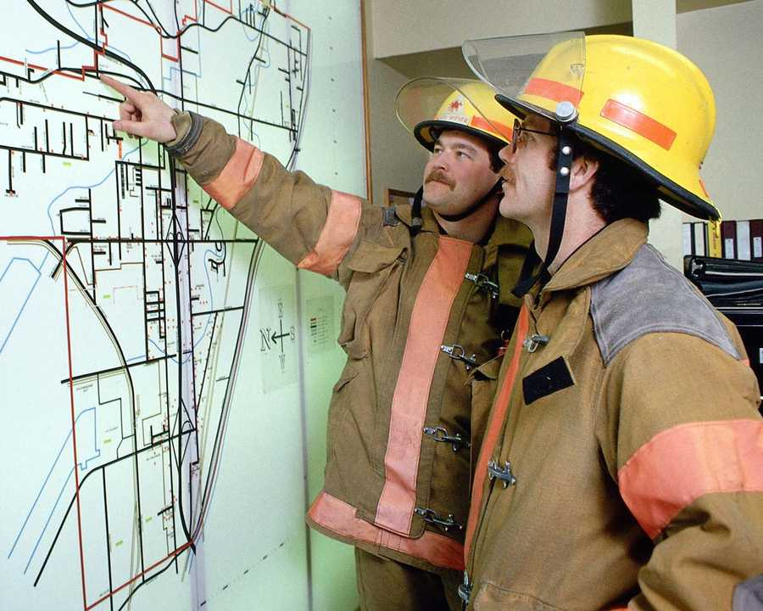


Representative Alex Beck. My co-sponsor and I discussing the
Foreign Aid For Birth Control Act.

6700 Lumsden St.
McLean VA
22101

John Doe
PA
456456

