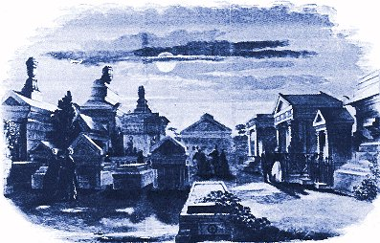

Poetry Is

The Sun Dawning

Over A Graveyard


By: Justin beck

