Nirvana
Album
Nevermind, Incesticide [as “New Wave” Polly]

Time: 2:57
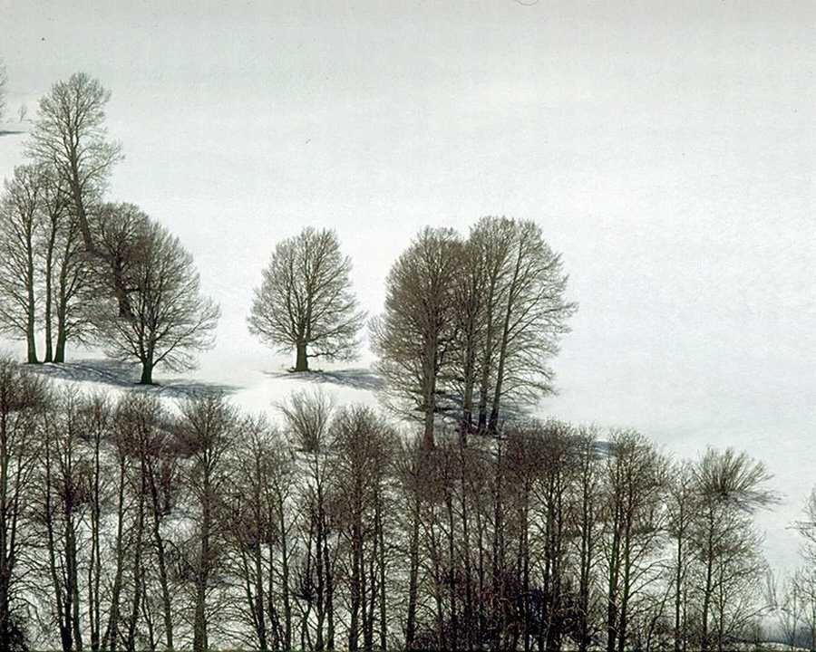

Polly wants a cracker
Think I should get off of her first
I think she wants some water
To put out the blow torch

It isn't me
We have some seed
Let me clip
Your dirty wings
Let me take a ride
Don't hurt yourself
I want some help
To help myself
I've got some rope
You have been told
I promise you

I have been true
Let me take a ride
Don't hurt yourself
I want some help
To help myself

Polly wants a cracker
Maybe she would like more food
She asks me to untie her
A chase would be nice for a few

Polly says her back hurts
And she's just as bored as me
She caught me off my guard
It amazes me, the will of instinct

