The first quarter project involved doing a research paper with a bibliography of five atoms with symbols that don’t sound like their names. However, in my infinite wisdom, I wrote about only one atom, potassium, whose symbol K derives from the Latin term for alkali, “kalium.” I told of its history and then the byproducts and their functions.

♣ Humphry Davis discovered the metal in 1807, when an experiment decomposed potassium hydroxide with a voltaic battery.
♣ Potassium oxidizes quickly and can react violently with water.
♣ It is commonly stored under a liquid such as kerosene and hydrogen gas.

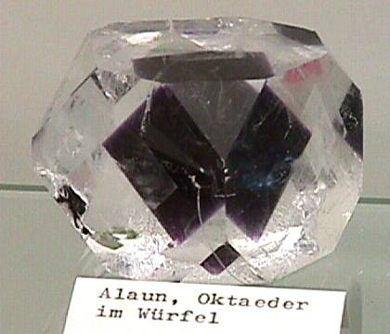

Potassium Alum

This project has helped me gain a better understanding of an element, not just that it is a few numbers and letters on the periodic table that I can manipulate for other work. I learned of the many compounds of potassium, such as potassium nitrate, used in detonators, and pyrotechnics. Potassium hydroxide is used in making liquid and soft soaps. Potassium chloride and potassium bromine also have many commercial uses.

