This worksheet involved balancing chemical equations in chemical reactions. Coefficients must be added so that the amount of each element is equal on both sides of the equations. This can be done by adding coefficients in front of the elements or compounds.

♦Chemical equation is a symbol that describes a chemical reaction and indicates identities and relative amounts of reactants and products.
♦A coefficient is a numeral used in a chemical reaction to indicate relative amounts of reactants or products.
♦In these equations, no new reactants or products can be added or taken away.
♦The relative amounts have been changed, but no atoms are left unaccounted for.
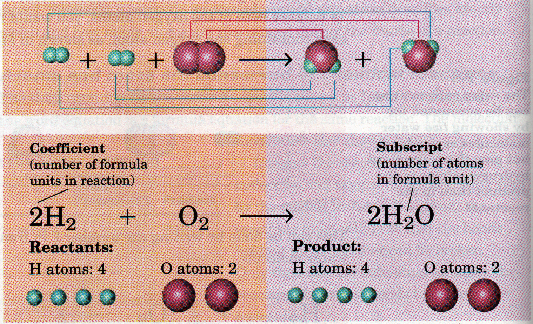

EX. 2h + O → 2h 0

EX. 2Fe + 3S → Fe S

This lab taught me how to balance chemical equations and identify and fix problems in incorrectly balanced equations. This is the foundation for Stoichiometry, making sure you have a sound equation before changing it from one form to another.

