For the second quarter project, I wrote an advertisement packet for titanium, Ti. I had to put the atomic weight, number and the electron configuration on the front. On the back, second fold, I wrote what Titanium was, its boiling point and its melting point. Also, the texture, malleability and ductility were reported. Then I told when and by whom it was originally founded.

♥ William Gregor, a British clergyman, originally discovered it in 1910, naming it menachite. It was rediscovered by Martin Heinrich Klaproth and renamed it Titanium.
♥ Pure Titanium is as strong as steel but 45 percent lighter.
♥ It is now used in place of aluminum in engine parts for jets, missiles and rockets.
♥ Its inertness makes it ideal for bone and cartilage in surgery, and other inner body uses.
♥ In its impure form it was brittle and useless, but a method for purification was found in 1910.

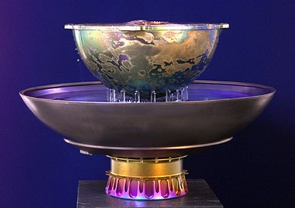
Titanium Fountain

As in the first project, I have learned more about an element than just its’ name, symbol and atomic mass. I have learned about the history, science and applied uses of this versatile metal.

