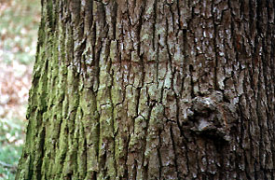

To further research this topic, I would explore many avenues of investigation. The first and most important of these is the exact nature of the chemical(s) in the tree bark which inhibited the bacteria? What is the nature of the process and how does it protect the tree? Where is the substance or chemical(s) replicated and does its characteristics vary in different tree species. I tried to research these questions using multiple different sources. Unfortunately, I did not find a great deal of this information in my sources. It would seem to be a very timely topic, but the only books that I found at the public library were fiction, children’s level books or books that used the word “tree” in the title. When I looked in the encyclopedia, it had some information but not much on many of the actual processes of a tree and very little on bacteria affecting trees.
Another interesting avenue would be to see if the leading pharmaceutical companies had performed research in this field, and what were their results with different trees. They would be the key researchers in this area because any findings that they made could result in a new astounding medicine. (This would enhance their profits too). I would like to know how they performed their experiments and how their methods differed from mine. I would like to know if they had come upon anything that was revolutionary or important scientifically.
There is a bounty of information on the topic of herbal remedies. Plants and herbs have been established as tools in fighting off many ailments. But what of trees? In all my research on alternative medicine and herbal remedies, I found only one mention of trees and their medicinal qualities.. This line of inquiry might assist in developing further experiments.
An experiment might identify a tree that had some effect on bacterial growth. Investigation of other trees in the same family might identify a tree with exceptional inhibiting power. These results might actually be used to develop medicines which would be of practical use.
Further experiments could alter several variables from the original. These include changing the length of incubation, using different incubation temperatures, varying the types of bacteria utilized, altering the type of agar, and extracting the bark using a different techniques. All in all the experiment that I have performed is just the tip of the iceberg.

