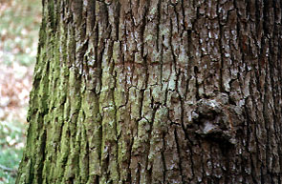

To further research this topic, I would want to look down many avenues. The first and most important of these, call it the “Broadway,” is the aspect of the tree bark and exactly how it does what it does. What chemical or chemicals inhibited the bacteria? What is the name of the process and how does it work. Where is the substance replicated and does the affect vary on different trees. I tried to find much of this information before but there was a dearth of actual scientific information. It would seem to be a very popular and dwelled upon topic, but the only book that I found at the public library were fiction, children’s level books or books that used the work tree in the title. When I looked in the encyclopedia, it had some information but not much on many of the actual processes of a tree and nothing on bacteria. So it gives me the impression that either I looked in the wrong places or wrongly or this field has not been stripped of all worth.
Another interesting avenue would be to see if the rich pharmaceutical companies had researched in this field, and what were their results with different trees. They would be the people to research this because any findings that they made could bring in money on a new astounding medicine How they went through this process or how their methods differed from mine. Had they came upon anything that was revolutionary or important scientifically.
There is a bounty of information on the topic of herbal remedies, plants and herbs that have been established as tools in fighting off many ails. But what of trees, in all my alternative medicine/herbal remedies searching on the web, I found only one mention of trees. This might help me in developing further experimentation. Perhaps do a correlation between the two and their zones of inhibition.
Doing continued experiments until I found a tree that had astounding results and then test the rest of that family of trees. It might identify results that might actually be put to practical use. Also, doing experiments but varying the amount of time spent, maybe lengthening the time period, in my case. All in all the experiment that I have done is just the tip of the ice berg.

