The purpose of this laboratory was to find the ration of moles of a reactant to moles of a product in a chemical reaction. The coefficients in a balanced equation indicate the number of moles of each substance. Thus, the ratio of moles of a substance to moles of any other substance in the reaction can be determined.

♥ The mole is defined as Avogadro’s number (6.02 x 10 ) of particle’s. In 1811, an Italian professor of physics named Amedeo Avogadro proposed a hypothesis which later determined the entire course of scientific thinking on gases and their composition.
♥ Avogadro made two guesses. Molecules of two atoms unlike solids or liquids gaseous elements exist in diatomic molecules and that equal volumes of gases at the same temperature and pressure contain the same number of molecules.
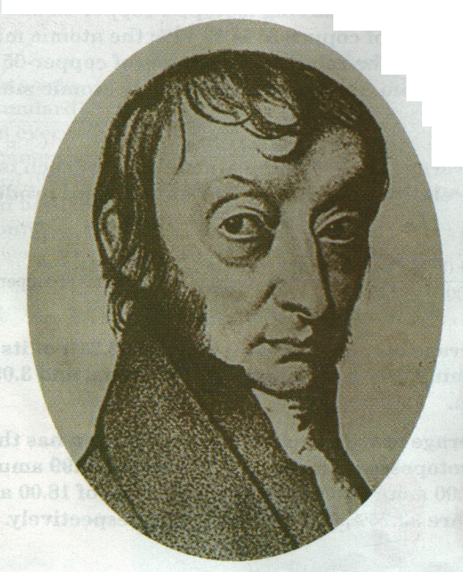

The formula was as follows: Fe(s) + CuSO (aq) FeSO (aq) + Cu(s).

The no. of gram-atoms = mass (g)
g-atomic mass.

The g-atomic mass of Fe is provided: 56 g Fe/g-atom Fe
The g-atomic mass of Cu is provided: 64 g Cu/g-atom Cu.

The mass of the copper produced was 8 grams. The number of g-atoms of copper produced was calculated by dividing 8 grams by 64 g Cu, to produce 0.125.
The mass of the iron used was 2.24 grams. The number of g-atoms of iron reacted was 0.04. This was calculated by dividing 2.24 by 56 g Fe

The whole number ratio of g-atoms of iron to g-atoms of copper was 8 : 25, derived from the ratio of .04 to .125.

I learned how to utilize the atomic masses to calculate the g atoms of a chemical and how to calculate whole number ratios of two chemicals. I also learned how to identify the limiting factor in a chemical experiment by finding which product is not present in large enough quantities to fully complete the reaction.

