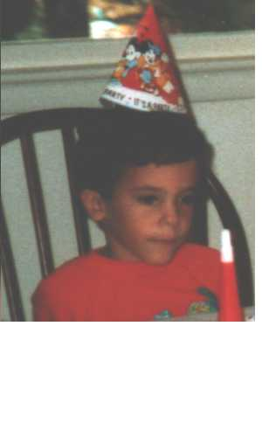Our Memories will have to do

So much blood for such a tiny little hole....
Nine Inch Nails
The Downward Spiral
I couldn’t have foreseen what happened to Leith Taima; and when I rummaged around in old photos, couldn’t have helped but notice how few recent or past pictures there were of him. And so it seemed a foregone conclusion that I’d pen my ideas about how and why I hadn’t taken advantage of the camera.
The photographs of Leith as a child and the one from about a year ago reflect the limited dimension of photos that I had of him. There were the birthday party shots and those when my friends and I were sitting around the house; and the two included picture reflect this reality.
So many ecstatic days and blissful throbbing nights escaped notice of the lens, the voyeur. Photographing events of people you’d know most of your life seemed unnecessary and irrelevant, untimely and awkward. In some part it was laziness and lack of foresight that no picture were taken, the pure experience was good enough.
But what is a photo’s true intention? It would help jog the mind into reminiscences and recollection of past times and places, the many sets in life’s show. A photo would etch a clear picture of Leith into my mind, help me to see anything but his shattered, immobile frame, curled or splayed like a rotting animal, flys lighting around his black and brackish congealed blood. Having pictures of Leith could never change what had happened or ease the pain, but it would give me a way to clear out all the murkiness in my memories. I could tear back the atrophied layers of time, to find some islands of cleanliness in the gory aftermath and foul memories of his slaying. It might clear the dark and intractable horror that had settled over my mind.
A picture might set off some reel in my head and glorious technicolor would hold me in its thrall. A laugh, a glance, words and grins and shining luminous eyes would have been absorbed to help flesh out the minds impressions. A moment of frigid lucidity, burning clarity could be recalled; or perhaps a smug face, a shudder, eyes aflame with anger, or hurt. All these infinitesimally small things that matter so much can be so easily forgotten; can slip away.
As the reader, you might imagine that I am now a chronicler of my life and those in it; an avid photographer. Laziness though, and the knowledge that when I and all those I’ve known pass away, all the many pictures will be nearly useless hieroglyphs to lives that matter no longer have kept me from this aim.

