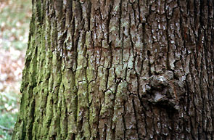

Do chemicals in tree bark {ie Pinus strobus (white pine), Cornus florida (flowering dogwood), Acer saccharinum (silver maple), and Acer rubrum (red maple)} have the ability to inhibit the growth of bacteria {ie E. coli and B. subtilis}.

