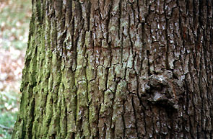

There were no discrete zones of inhibition at 24 and 48 hours. However, contaminating bacteria were present around each bark soaked disc and in areas where the water had spread out from the disc. At 72 hours, however, discrete zones of inhibition were identified. None of the four bark types inhibited growth of Bacillus subtilis. All of the four bark types showed at least partial inhibition of the E. coli. The largest zones of inhibition occurred with the silver maple bark. It had an average zone of inhibition measuring 1.70 cm. This tree is the largest and oldest tree in our yard and was the largest tree used for bark collection. One could speculate that it is the best suited tree to fight bacteria. Our younger and smaller red maple tree displayed a smaller zone of inhibition (1.43 cm). The pine tree was similar at 1.375 cm and the dogwood displayed the smallest zone of inhibition (1.025 cm).

