The purpose of this lab according to the cover page was to investigate chemical change and observe a chemical reaction to see if was altered. This was probably to prove the Law of Conservation of Energy in which it cannot be added nor taken away, merely changed.

♦ The group measured 20 mL of copper sulfate in Erlenmeyer flask, and then 5 mL of sodium hydroxide into a test tube that was placed in the Erlenmeyer flask.
♦ The measurements were taken so we could see if the mass had changed after the chemical reactions.

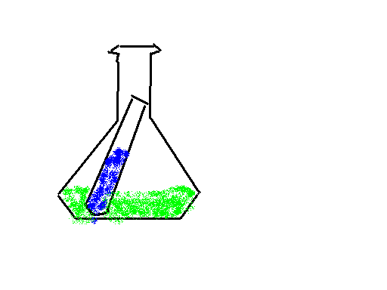

♦ The measurement came out to 187.08 before and 187.07 after. This proved that nothing was taken away or added, merely changed.

Formula = Mass of flask and test tube with substance – mass of the two substances.

This experiment has helped us to understand the difference between chemical and physical reactions. It also helps us comprehend how things like plastics and such are made, using chemicals and knowing how they will harden and form new things. This helped us to learn how to do accurate lab measurements.

