The purpose of the Iron Chameleon Laboratory was to predict and then experimentally determine the identity and mass of a solid product when a known mass of iron was reacted with copper sulfate solution.

♥ Copper sulfate is a salt that can form a hydrate. A hydrated crystal is salt that has the ability to bind water molecules within their lattice structure.
♥ Many pure anhydrous salts will absorb moisture from the air to form hydrates.
♥ Iron is the most abundant, widely used, and least expensive metal.
♥ Iron can be galvanized to protect it from rust and corrosion. This is done by coating it with a protective layer of zinc.
♥ Iron, nickel and cobalt all occur in pure form in nature and, oddly enough, they all occur together.
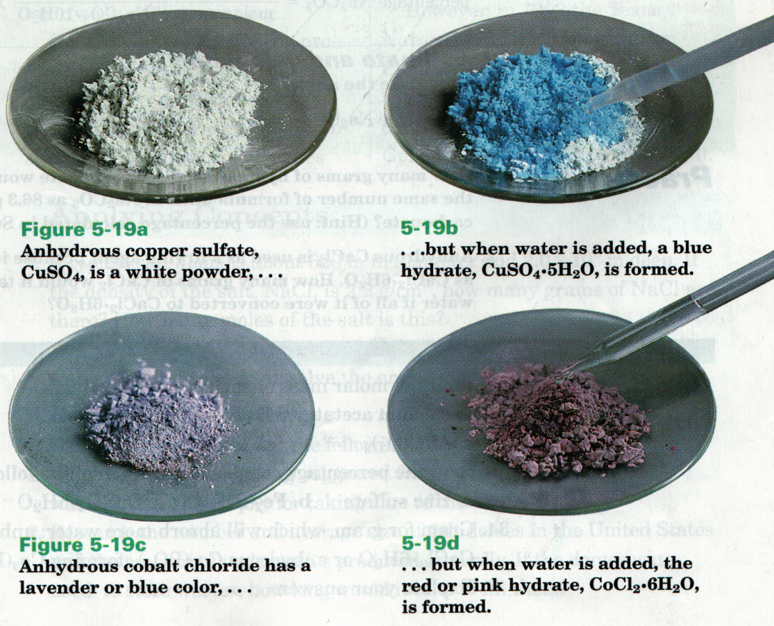

Reaction’s Equation: Fe + CuSO FeSO + Cu

The type of reaction demonstrated in this laboratory was a single replacement reaction. A single replacement reaction occurs when a single element in a compound is replaced by another element in the product.

The calculations for this lab included subtracting the weight of the beaker from the weight of the beaker plus product to find the weight of the product. Ie 64.42 – 61.94 = 2.48 grams. The percent yield was calculated by subtracting the mass of the product from the mass of the iron prior to the reaction. 2.48 – 2.04 = .44. This represents a percent yield of 21.9 %.

I learned that mass can be gained during a chemical reaction. I learned that hypotheses can be incorrect. I also learned how to calculate percent yield and percent error.

