These Stoichiometry problems helped the student practice changing things from molecules and grams to moles. It also asked the student to change mass to grams and convert moles to number of molecules. On the back was a diagram much like your “Mole-Finding” worksheet in which the process of finding the different units was detailed.

♠The stoichiometric equation calculates mass and quantity relationships among reactants and products in a chemical reaction.
♠The molar masses of the substances are generally required.
♠Make sure the unit is in grams, not kilograms before beginning.
♠Now determine the mole ratio by putting your number of grams over the substance’s atomic size, including all things that make it up.
♠Now multiply the mole ratio of how many moles of the thing you want to find over the one that you already have.
♠ Then you use the thing you want’s molar mass and multiply to find what you want.

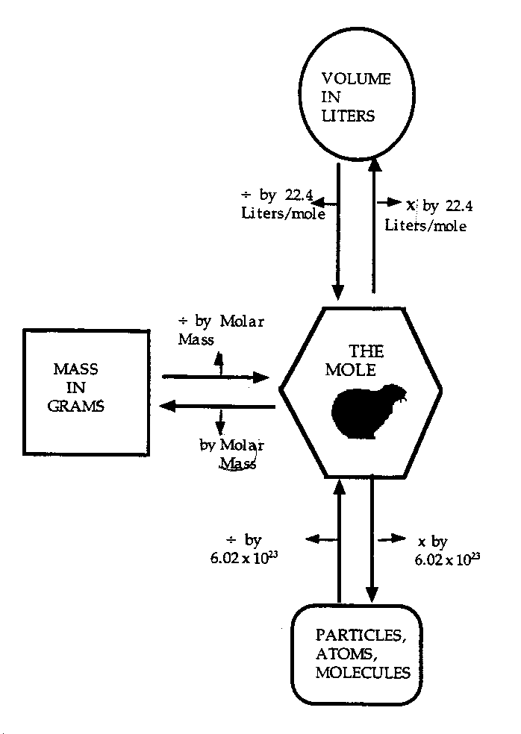

EX. Mass to grams– 5 moles NH = 85 g
EX. Moles to molecules- 2 moles CO = 1.2044 E24

I learned from this the process of changing units for stoichiometric purposes. This knowledge made it easier for me to understand the more difficult equations.

