I Was Wondering If Your Company, AC ANSEN CRAFTS Official Store, Would Like To Sell A Product I Personally Designed Which Is A Complete Shark FX Software Design Of A Ridged Double Sided Coin To See If www.aliexpress.com Would Sell The Coin Manufactured At www.alibaba.com Factories And Sent Directly To AC ANSEN CRAFTS Official Store Warehouses For My Profit.
!!!!!PICTURES MUST BE SENT FROM E-MAIL CLIENT!!!!!
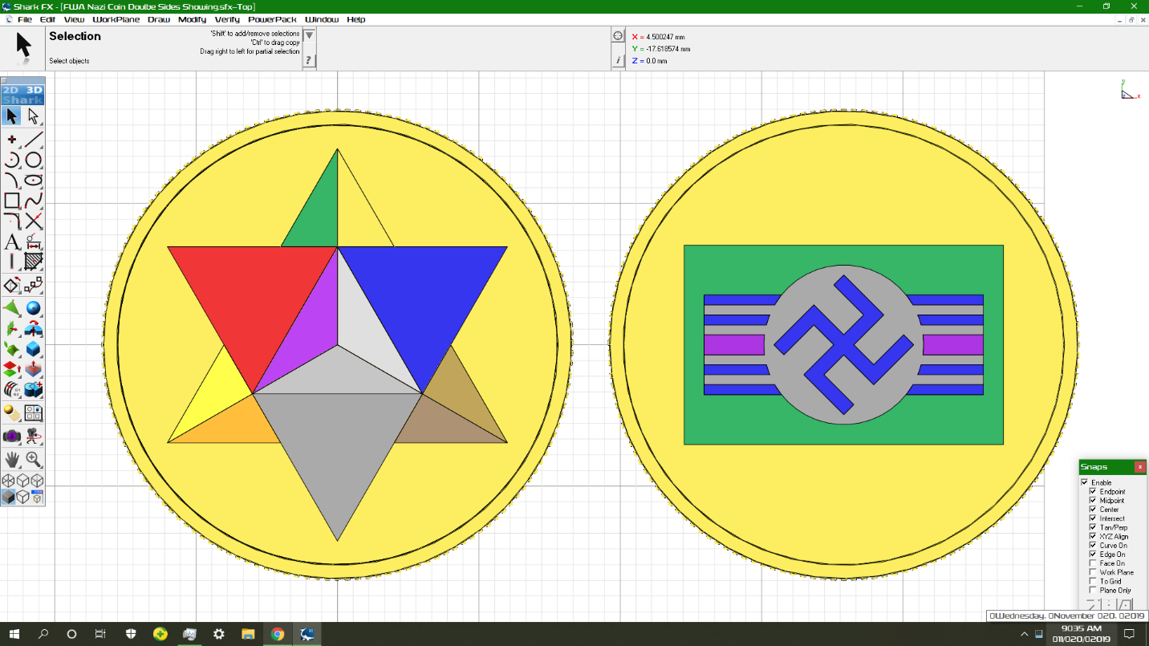
!!!!!PICTURES MUST BE SENT FROM E-MAIL CLIENT!!!!!

!!!!!PICTURES MUST BE SENT FROM E-MAIL CLIENT!!!!!
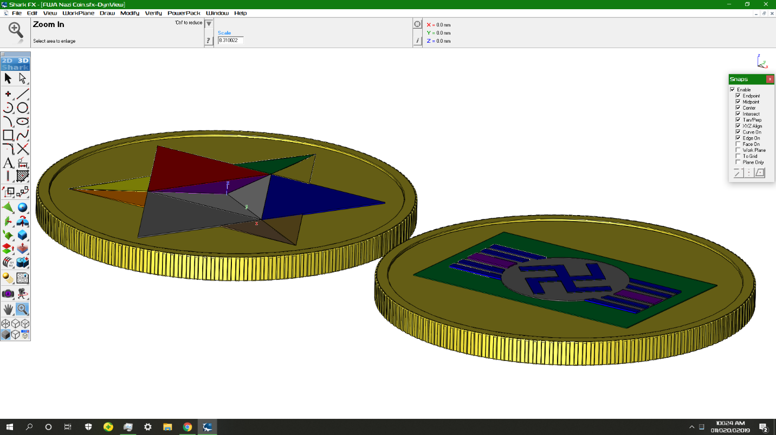
!!!!!PICTURES MUST BE SENT FROM E-MAIL CLIENT!!!!!

Would AC ANSEN CRAFTS Official Store Be Willing To Sell This 30 mm x 2 mm Multi-Colored Mirror Finished Coin For $1, No Shipping Or Handling Fees, And Never Have It Go On Sale That I Would Order Manufactured At An www.alibaba.com Factory For My Profit.

I Would Want Your Factory To Produce And Ship To Me Around 400-1000 Metallic Mirror Finished Color Designed Gold Plated Backgrounded 30 mm x 2 mm Stainless Steel Coins I Personally Designed And Have The Shark FX File Of With No Licensing Deal Except This Single Current Hopeful Asny Craft Factory Manufacturing Order Through www.alibaba.com. I Would Want The Electroplating To Be 36 Microns Around All 12 Metallic Mirror Finished Colors Exactly Matching The Colors In The Designs If Right Clicked And 36 Micron Gold Plating Also Mirror Finished All Around The Designs On Both Sides Of The Coin And In The High y Low x Triangle In The Jew Star Looking From The Top That Shows As The Exact Same Gold Looking Color I Choose For The Coin Designs’ Background.
The Entire Design Is Finished Except There Are Still Sharp Edges In The Designs. There Are Not Any Sharp Edges In The Coin Backing And Ridges. I Hope You Will Be Able To Correct The Sharp Edges Instantly And Automatically With Your Systems Otherwise I Will Have To Do That On My End With Shark FX Manually Before It Gets Produced If I Am Happy With The Price.

Here Is The FWA Nazi Coin Design

Would The Brass Choice Be Shiny Gold All The Way Through The Coin, If So I Would Want Brass.

I Want The Whole Surface Of The Coin To Look Like This Kind Of Surfacing On The Green Of The Pen But The Colors On The Picture Besides The Gold Triangle Next To The Green Triangle And Background:
!!!!!PICTURES MUST BE SENT FROM E-MAIL CLIENT!!!!!
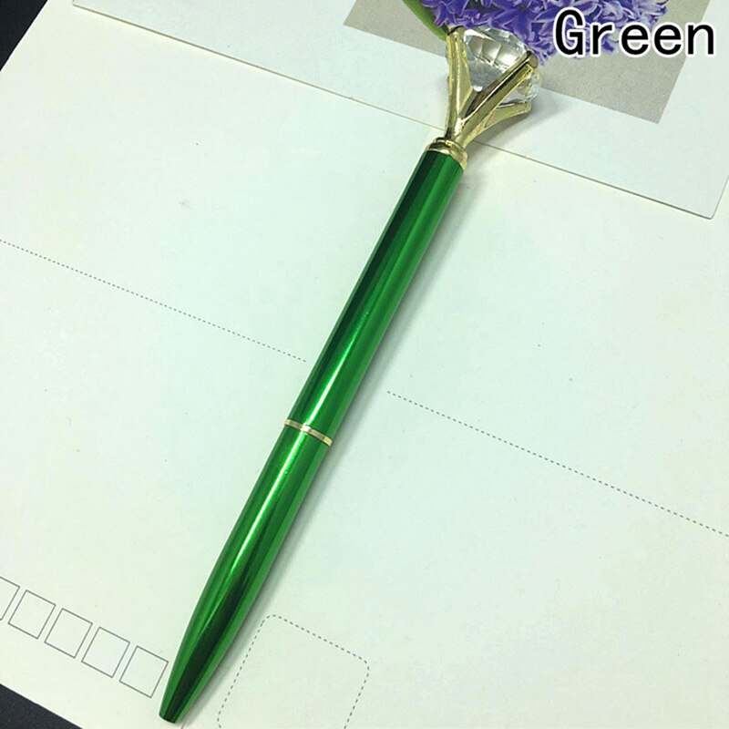
!!!!!PICTURES MUST BE SENT FROM E-MAIL CLIENT!!!!!
Can Your Factory Make All The Colors In The Design Including White Shaded, NonGold Yellow Looking, And Black Looking Shiny Mirror Finished Acrylic Like The Green Of The Pen?

I Was Wondering If Dongguan Cixin Hardware Jewelry Factory Is Able To Manufacture Stainless Steel Core 36 Micron Thick Gold Plated Coins Where The Coins’ Designs Are Surfaced 36 Micron Thick The Same Way As The Metallic Mirror Finished Blue Cross Layer In “Wholesale Mens Polished 316L Stainless Steel Jewelry Star Cross Necklace Pendant Fashion Blue Multi-layer CZ Diamond Pendants” Except Exactly Matching The Color Of Each Element In The Shark FX Design File{http://www.scimagorder.com/Pictures/FWA%20Nazi%20Coin%20Doulbe%20Sides%20Showing.sfx} When Right Clicked.
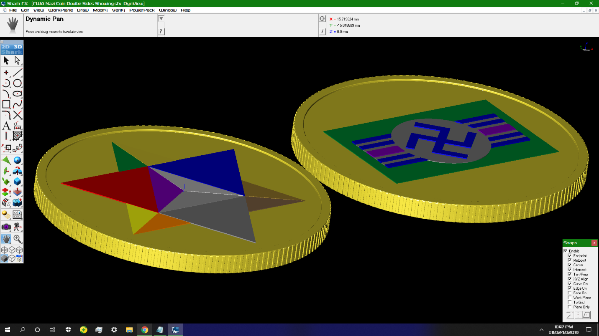

Skip Below If They Can.

Yellow Right Next To Orange And White Directly Above Black Acrylic Like Yellow Paint And Acrylic Like White Paint Respectively. All Other Colors Mirror Finished Acrylics With Gold Everywhere Else Including Triangle Next To Green.

Skip Above If They Can.

2 Face Designs Need Rounded At The Very Tips Of The Edges So As Not To Have Sharp Edges. The Triangle Connected Over The Most Length To The Blue Triangle Is Meant To Have A Stainless Steel Chrome Finish And The Black Triangle At The Bottom Of The -y Direction Is Black Like It Says If You Right Click On It Like The Area Directly Around The Swastika.

Is The Colored Metal Going To Be Plated On The Thin Depth Part Of The Designs That Give The Designs The 3 Dimensional Feel?

.stl File Transfer After .sfx Check
Colored Enamel Finish.
How Much Is The Casting?

Since The Coin Is Not In Color Can You Automatically Calibrate The Enamel Colors Based On The 2 Pictures That Look Like The Design And Skip The Golden Triangle Right Next To The Green Triangle Since That Is Supposed To Stay The 36 Micron Gold Plating.

I Would Want The 2 Greens To Be 2426 C, The Orange To Be 2018 C, The Red To Be 2347 C, The 2 Purples To Be 2597 C, And The Bronze To Be 7551 C, The Gray 4239 C, The White -> White Enamel

Will The Colored Enamel Thickness Be Equivalent In Scratch Resistance To The 36 micron Thick Gold Plating?

Will The Coin’s Designs Protrude Beyond The Coin’s Rim After The Enamel Surfacing?

Can The Stainless Steel Coin Be Cast And As Rapidly Cooled As Possible.

Can The Coins Come In Paper Rolls and Not In Cases. And Can The Bunch Of Rolls For The Box Be Put In A Thick Transparent Sealable Ziplock Bag. And The Bag Put In A Bubblewraped Box.

So The 30 mm x 2 mm Stainless Steel Coin Core Will Be Cast Then Gold Plated By Electrophoresis 36 microns Then The 11 Colors Of Enamel Will Be Applied To The Designs Then Packaged And Shipped To Me In A Set Of Rolls In A Sealed Bag In Bubble Wrapped Box(s).

I See The Topmost And To The Right Triangle Is Holed Out Where It Was Supposed To Be Gold Plating, What Were You Planning On Doing With That?

If It Has To Be Enamel The Yellow Looking Pantone Color At 603 C Would Be Best.
I Guess I Will Wait For The Unit Price Quotes And Expect To Just Pay A Little Bit For DAP - Delivered At Place, With Aliexpress’s Free Shipping Standard Month Long Wait Air Freight With EMS Or China Post Or Something To USPS{United States Postal Service} Like Aliexpress.com Does. My Place Is 7358 Lee Highway Apartment 201, Falls Church, Virginia, 22046, USA And If I Get The Tracking Number I Will Be Available To Take The Package(s) In When They Arrive. I Don’t Want To Pay Wire Transfer Fees Over And Over Again Anyways.
Does http://www.ems.com.cn/ Have A Standard Pickup From Your Factory, If So Could The Shipment Of The Many Coins Come EMS To USPS{United States Postal Service} With Their Standard Shipping Lane{I Guess Through JFK Airport In New York} To My Apartment At The Address I Gave You.
If Not Is There An Outbound China Post Shipment Or Your Preferred Outbound Carrier That You Can Label The Packages For, For Delivery To America By aliexpress.com’s Preferred Carrier In My Country; USPS.

Will That Take The Express Shipping Fee Away, And Will There Be Wire Transaction Fees If I Use MasterCard Or Does The MasterCard Just Get Charged 2.95% of payment amount.

Price Scheme
Only Give To Me If You Have Confirmed With FWA@FreeWorldAlliance.co That I Will Actually Be Able To Get The Money Personally
Sold At $1 On Aliexpress.com $0.25 To My Koffers
Sold At $4 On Amazon.com $1 To My Koffers
Sold At $100 From Fools Gold Salesman Who Owe The FWA Support Somehow To Get Extensive Support From Us.
Sold At $400 From Real Gold Traders $10 To My Koffers For Support, Legal Help, And Proof Of Gold Value Necessity Up To And Including Advanced Technical Details About What Gold Actually Is To Scientists With Brief Explanation Of The Ashkenazi Jewish Conspiracy.
Sold At Another Price Of Gold Above $400 %2.5 For Potential Support And Brief Verbal Support To People Complaining And Legal Templates To Write The Court With If Trouble Brews.
When Gouging Occurs Judgments Shall Be Made By The Free World Alliance.
In Jainism The FWA Nazi Gold Coin Is A Compactable Winged + Bladed + Plasma Riffled + Belted + Support Backpacked, Viacad Empire Standard Medium Support Stex{Strength Enhancing Exoskeleton} Of Any Color.

Kosher Play Nazi Gold Made Of Stainless Steel Gold Plated + Colored Metallic Mirror Finished Coin For Dreaming Strength Enhancing Exoskeleton
Price: | $4.00 FREE Shipping on orders over $25.00 shipped by Amazon or get Fast, Free Shipping with Amazon Prime & FREE Returns
- High Quality Thickly Plated Colored Gold Coin To Safely Play With Lost Nazi Gold Envisioning The Nazi Secret Sky Command Weapons Development Program That Would Have Saved Hitler Before The Allied Forces Went Into Germany.
- Also Can Be Safe Childrens’ Collectable Coin To Dream About Unregulated Lost Nazi Gold Found After World War 2. Swastika Made Safe Not Only From Flashing Colors From Red And White But Also Similar Bars As Had On Allied Vehicles In World War 2.
- 3-D Jewish Star Is On Heads Side To Show That The Coin Is Completely UnAntiSemitic In It’s Nature As A Collectible Dream Coin Of Lost Nazi Gold.
- Can Also Be A Leprechaun Coin That Enchants A Childs Imagination About Jewish Or Nazi Gold For Everybody Envisioned And Designed In America By The Free World Alliance.
- The Cherishable Coin Is 30 mm x 2 mm in Size And Weighs 9.6 Grams.
- Made Very Durable And Well Protected From Tarnishing In Mainland China.
Package Dimensions | 2.? x 2.? x 0.? inches
Item Weight | 0.? ounces
Shipping Weight | 2.? ounces (View shipping rates and policies)
ASIN
Manufacturer recommended age | All Ages.

If Amazon.com Order Moves Through Or You’re Willing To Demonstrate The Product And Give Me High Res Pictures Of It.

After The Coins Are Completed Can I Get A Video Showing 2 Coins Moved Against Each Other And Played With Under Proper Track Lighting To Show Off The Mirrorness Of It And Get A High Resolution Photo Of The Reflective Shine In The Colored Metallic Mirror Finished Part In Both Sides Of 2 Coins With Opposite Faces Showing. 1 From A Sharp Diagonal To Show The Coins Depth And 1 From The Top.

Is The Sample Ready Yet?

That Looks Great. I Will Buy The Main Lot Of Them. What Are The Price Quotes?

