Kosher Play Nazi Gold Made Of Stainless Steel Gold Plated + Colored Enamel Coin For Dreaming Strength Enhancing Exoskeleton

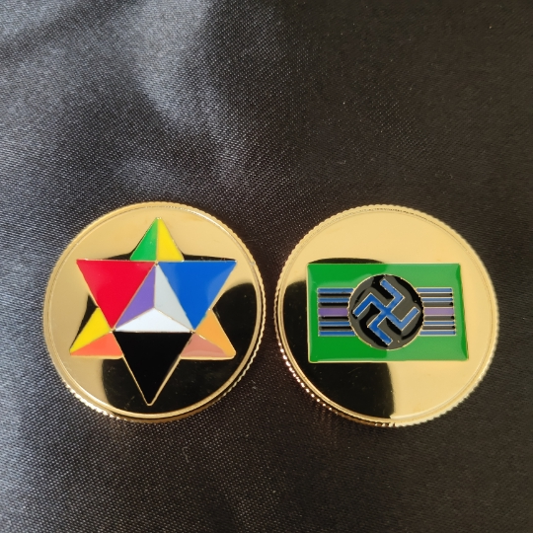

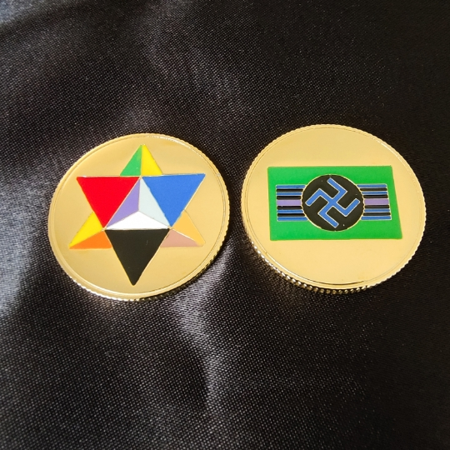
Price: | $4.00 FREE Shipping on orders over $25.00 shipped by Amazon or get Fast, Free Shipping with Amazon Prime & FREE Returns
- High Quality Thickly Plated, Thickly Enameled Colored Gold Coin To Safely Play With Lost Nazi Gold Envisioning The Nazi Secret Sky Command Weapons Development Program That Would Have Saved Hitler Before The Allied Forces Went Into Germany.
- Also Can Be Safe Childen’s Collectable Coin To Dream About Unregulated Lost Nazi Gold Found After World War 2. Swastika Made Safe Not Only From Flashing Colors From Red And White But Also Similar Bars As Had On Allied Vehicles In World War 2.
- 3-D Jewish Star Is On Heads Side To Show That The Coin Is Completely UnAntiSemitic In It’s Nature As A Collectible Dream Coin Of Lost Nazi Gold.
- Can Also Be A Leprechaun Coin That Enchants A Childs Imagination About Jewish Or Nazi Gold For Everybody Envisioned And Designed In America By The Free World Alliance.
- The Cherishable Coin Is 30 mm x 2 mm in Size And Weighs 8.4 Grams.
- Made Very Durable And Well Protected From Tarnishing In Mainland China.
Package Dimensions | 2.? x 2.? x 0.? inches
Item Weight | 0.? ounces
Shipping Weight | 2.? ounces (View shipping rates and policies)
ASIN
Manufacturer recommended age | All Ages.

