Manufacturing Costs
Affixed At Below Value For Mr. Beck’s Profit
$0.15 A Coin For >=10000, 250 Rolls
$0.16 A Coin For >=2000, 50 Rolls
$0.18 A Coin For >=1000, 25 Rolls
$0.20 A Coin For >=400, 10 Rolls
$0.24 A Coin For >=120, 3 Rolls
$0.25 A Coin For >=40, 40 In 1 Roll

Alibaba.com Product Post
$0.75-$2.50 Per Coin
$1.50 A Coin For >=10000, 250 Rolls
$1.60 A Coin For >=2000, 50 Rolls
$1.80 A Coin For >=1000, 25 Rolls
$2.00 A Coin For >=400, 10 Rolls
$2.40 A Coin For >=120, 3 Rolls
$2.50 A Coin For >=40, 40 In 1 Roll
M.O.Q. 40 Coins.

Alexander Gerhard Beck’s Profit
$0.50-$2.35 Per Coin
$1.35 A Coin For >=10000, 250 Rolls
$1.44 A Coin For >=2000, 50 Rolls
$1.62 A Coin For >=1000, 25 Rolls
$1.80 A Coin For >=400, 10 Rolls
$2.16 A Coin For >=120, 3 Rolls
$2.25 A Coin For >=40, 40 In 1 Roll

Preferred Aliexpress.com Sales
Bought 10000 At A Time For $1.50 Per Coin
$2.00 A Coin Free Shipping.
$1.90 A Coin For 40 Coins; 1 Roll, Free Shipping.

Jewish Melt Down Value
Owner’s Hit Point Mass In Gold At The Price/Mass And Quality; It Is Free World Alliance Medium Support Sinss MMA Stex{Strength Enhancing Exoskeleton} For Pixies And Preferred Banshees. Also Is Ideal Coin Container For Pixie Universe Generator Even While Stex Is Deployed.

Remember Angels Protect Against Riches Forming That Are Not Real!
Price Scheme
Only Give To Me If You Have Confirmed With FWA@FreeWorldAlliance.co That I Will Actually Be Able To Get The Money Personally

Sold At $2 On Aliexpress.com $1.35 To My Koffers
Sold At $4 On Amazon.com $3 To My Koffers
Sold At $100 From Fools Gold Salesman Who Owe The FWA Support Somehow To Get Extensive Support From Us.
Sold At $400 From Real Gold Traders $200 To My Koffers For Support, Legal Help, And Proof Of Gold Value Necessity Up To And Including Advanced Technical Details About What Gold Actually Is To Scientists With Brief Explanation Of The Ashkenazi Jewish Conspiracy.
Sold At Another Price Of Gold Above $400 %50 For Potential Support And Brief Verbal Support To People Complaining And Legal Templates To Write The Court With If Trouble Brews.
When Gouging Occurs Judgments Shall Be Made By The Free World Alliance.
In Jainism The FWA Nazi Gold Coin Is A Compactable Winged + Bladed + Plasma Riffled + Belted + Support Backpacked, Viacad Empire Standard Medium Support Stex{Strength Enhancing Exoskeleton} Of Any Color; A “SciMag Stex”.

www.alibaba.com To Angels
$0.15 A Coin For >=10000, 250 Rolls
$0.16 A Coin For >=2000, 50 Rolls
$0.18 A Coin For >=1000, 25 Rolls
$0.20 A Coin For >=400, 10 Rolls
$0.24 A Coin For >=120, 3 Rolls
$0.25 A Coin For >=40, 40 In 1 Roll
M.O.Q. 40 Coins.

www.aliexpress.com To Pixies
$2 For 1

www.amazon.com To Ler Girlz
$4 For 1 + $3.99 Shipping If Less Than $25

To Banshees
$40-$100 For 1

To Bitches
$400 For 1

To Stupid Bitches
+$400 For 1

To Total Bitches
Price Gouged For 1

Kosher Play Nazi Gold Made Of Stainless Steel Gold Plated + Colored Enamel Coin For Dreaming Strength Enhancing Exoskeleton

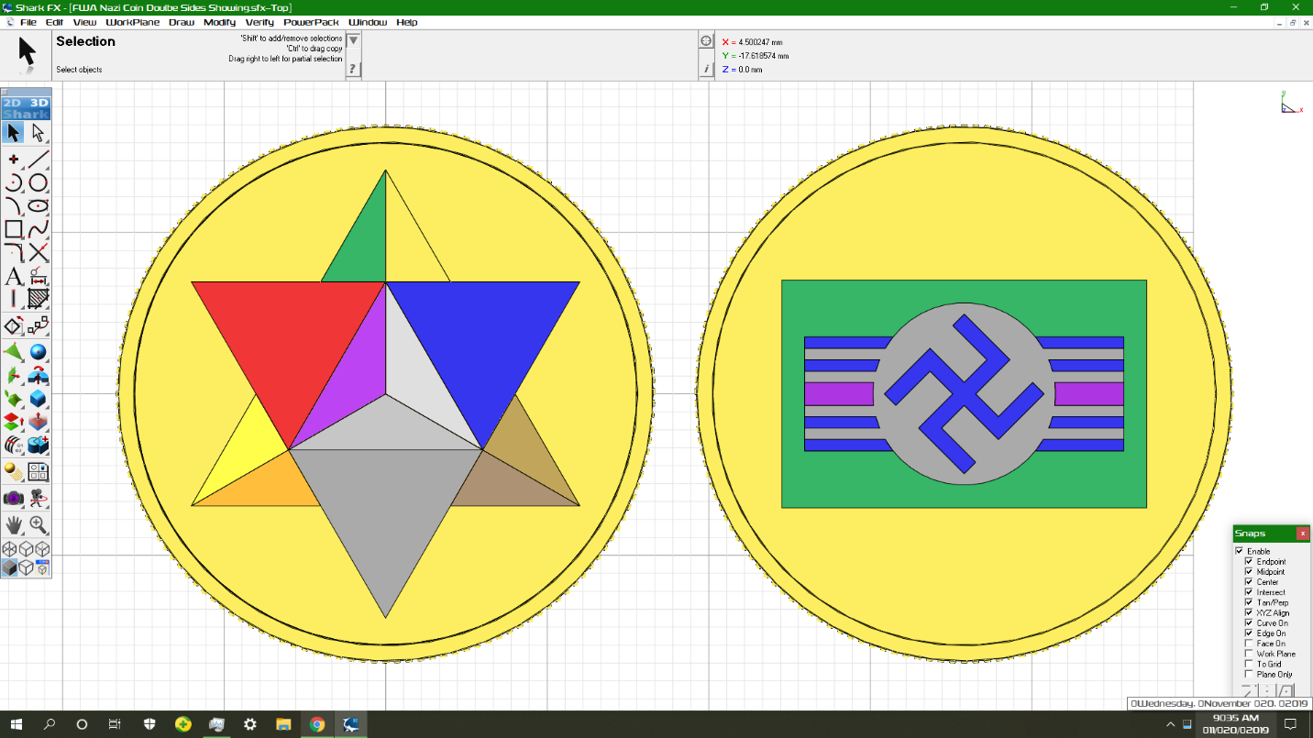

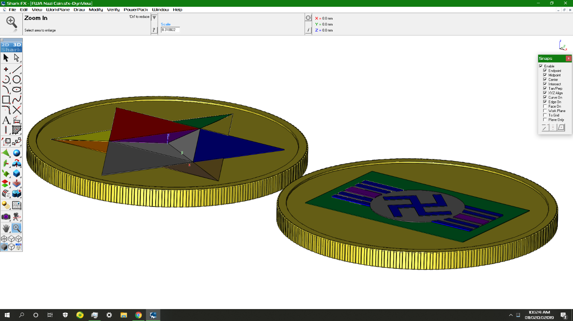
Price: | $4.00 FREE Shipping on orders over $25.00 shipped by Amazon or get Fast, Free Shipping with Amazon Prime & FREE Returns
- High Quality Thickly Plated, Thickly Enameled Colored Gold Coin To Safely Play With Lost Nazi Gold Envisioning The Nazi Secret Sky Command Weapons Development Program That Would Have Saved Hitler Before The Allied Forces Went Into Germany.
- Also Can Be Safe Childen’s Collectable Coin To Dream About Unregulated Lost Nazi Gold Found After World War 2. Swastika Made Safe Not Only From Flashing Colors From Red And White But Also Similar Bars As Had On Allied Vehicles In World War 2.
- 3-D Jewish Star Is On Heads Side To Show That The Coin Is Completely UnAntiSemitic In It’s Nature As A Collectible Dream Coin Of Lost Nazi Gold.
- Can Also Be A Leprechaun Coin That Enchants A Childs Imagination About Jewish Or Nazi Gold For Everybody Envisioned And Designed In America By The Free World Alliance.
- The Cherishable Coin Is 30 mm x 2 mm in Size And Weighs 9.6 Grams.
- Made Very Durable And Well Protected From Tarnishing In Mainland China.
Package Dimensions | 2.? x 2.? x 0.? inches
Item Weight | 0.? ounces
Shipping Weight | 2.? ounces (View shipping rates and policies)
ASIN
Manufacturer recommended age | All Ages.

The FreeWorldAlliance.co WebRing Of 63 Domain Names Is About Freeing All People To A Benevolent E-Democracy.biz To Get Started Goto NanoFirm.org The WebRing Index Is At RosticurianOrder.com

Product Deployer Cost
To Actually Get The Coin To Sell Widely At $400.00
Buy As Many As You Want To Sell For $222.15 From Any Online Real Sounding Gold Seller. Sell Legitimately At Fixed Price Of $400 Or Around Price Of Gold Or Platinum. $200 Will Go To Me Dr. Alexander Gerhard Beck aka Avar Dr. AllA Erawa Viacad, $0.15 Will Goto To Supposed Manufacturing Costs If It Were Not For East Azn Mysticism.
All Product Deployers Are To Pay $200.15 Per Coin To Me To Get 10,000 Coins. $2 Is For Any Commission Which Is Not Waivable. $20 Is For The Online Gold Seller. $0.15 Is For Manufacturing Costs.
I Will When Receiving The $2,001,500.00 Order 10,000 Coins To The Online Gold Seller Location. www.Alibaba.com Will Ship Directly To The Address You The Online Gold Seller Must Give To Them Precisely And Accurately And Not Change For Each Shipment Nor For Any And All.
Scientifically Speaking Gold, Platinum, Gems, And Riches If Intact, Shiny, Sparkly, And Beautiful Is Always Real. The Black Knights Just Lie And Claim Otherwise With The Media/Internet Empire. If It Does Not Have The Jainist Value As A Stex And Potential Universe Generator Which Protects The Universe Even When Deployed Around Your Body, It Is Still Gold To Real Experts.
www.magicguild.net Has The Starter Information On “Fools” Gold.
www.scimagorder.com Has Information On Why It Is Valuable Deep Into The Webpage If You Have Ability And Analysis To Figure It Out.
www.universegenerator.com Has Information About Why Universe Generators Are Real.
www.pixies.zone Is The Best Website For Beginning To Explain To Them About The Strength Enhancing Exoskeleton Thing, Because They Will Get How It Could Be Real And That You Could Be Innocent In Believing In It If They Watched Star Trek Or Star Wars Or Something.
If They Claim To Dispute The Science Behind It Tell Them To Goto www.self-replicatingnanobot.com And Dispute That With Openly Published Material Otherwise Even The Claim About The Stex Can’t Be Proved Wrong And The East Azn Mysticism That Proves “Fools” Riches Value Can Be Proved Calling Into Mainland China.
Angels Do Make Sure It Only Looks Real If It Is Real, So Look Into That As The Actual Proof That The Screwed Up Peasants Will Get If They Either Listen To The Proper Authority Or Don’t Sell Their Soul To The Devil!

